Git Repo: <https://github.com/Hariae/CMPE273-SP19-18>

# Canvas: Learning Management System:

## Goal and Purpose:

This project aims to build a Canvas: Learning management system that makes teaching and learning easier. Proposed solution aims to develop client server-based distributed web application using Node, Express, React and MYSQL.

## Chosen System design:

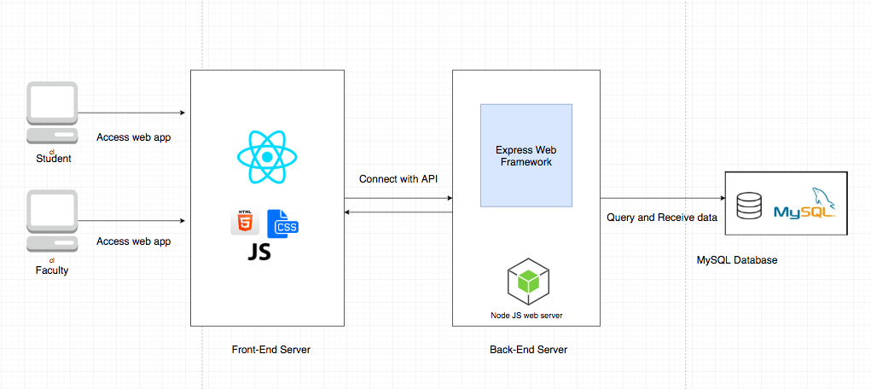

#### NodeJS:

NodeJS is used to create RESTful services in application as it is very powerful JavaScript-based framework to develop I/O intensive web-based applications.

NodeJS is single-threaded and it employs a concurrency model based on an event loop.

It registers a callback and allows the application to instead of blocking the execution.

So NodeJS can scale very well as it can handle concurrent operations without creating multiple threads of execution.

#### ExpressJS:

I am using Express JS along with Node JS as it is a light-weight web application

development framework and it provides various simple API to build our web application.

#### ReactJS:

View Layer of an application is developed in ReactJS.

##### ***Sign-in and Sign-Out page:***



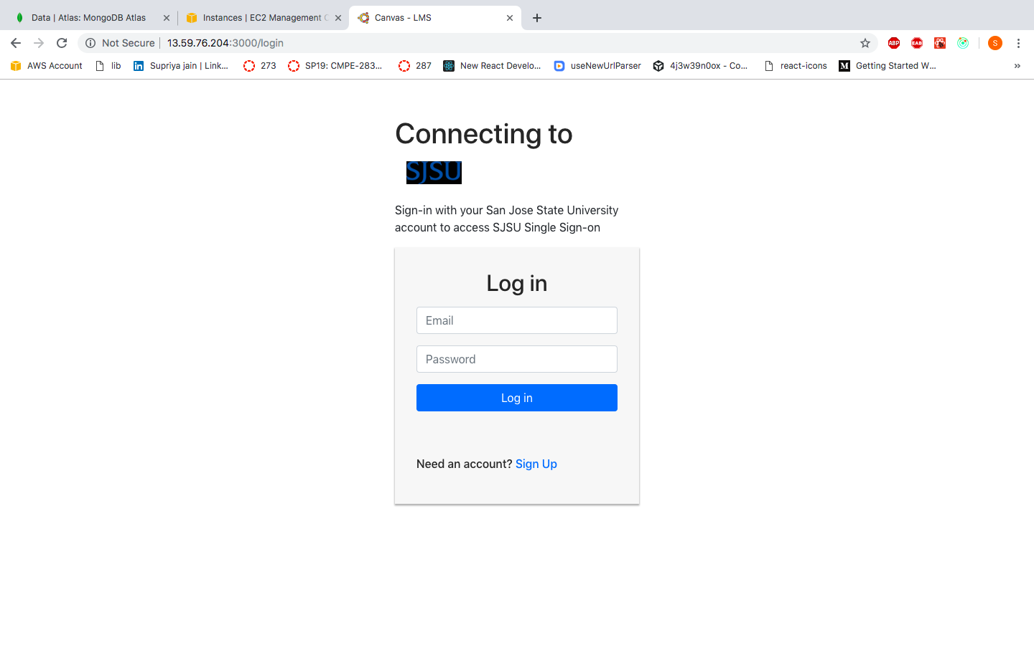

# 

# 

##### ***Login flow: Kafka, Kafka backend and redux logs:***

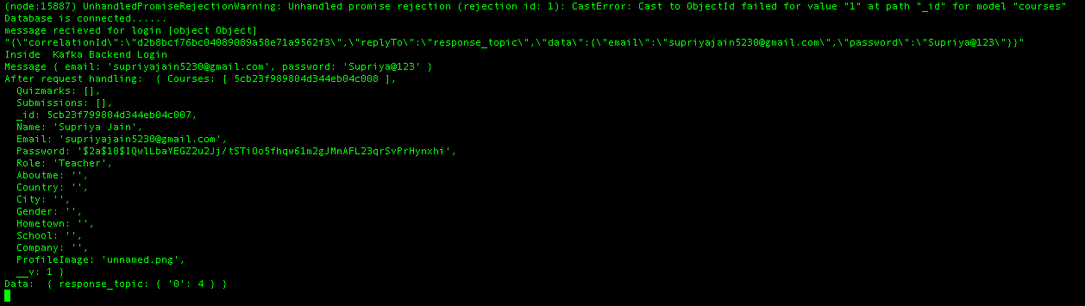

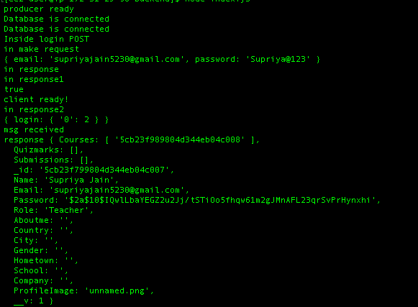

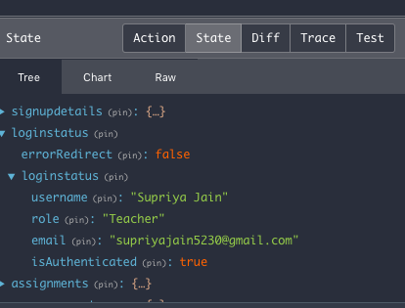

##### ***SignUP flow: Kafka, Kafka backend and redux logs:***

Validations error:

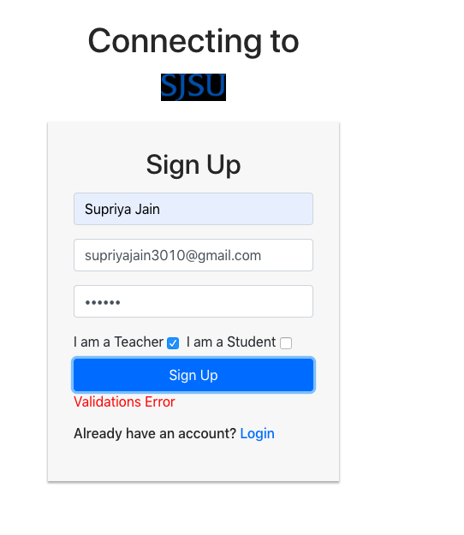

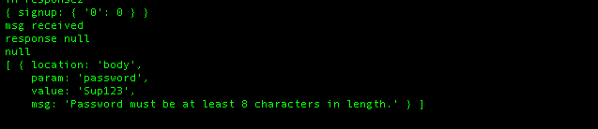

Signup flow:

Validations

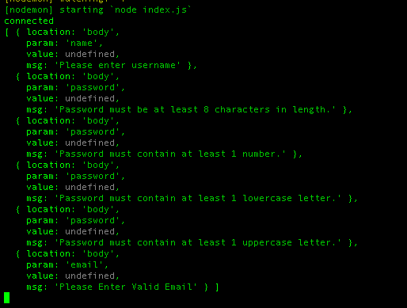

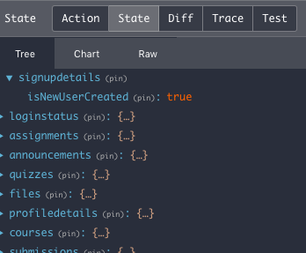

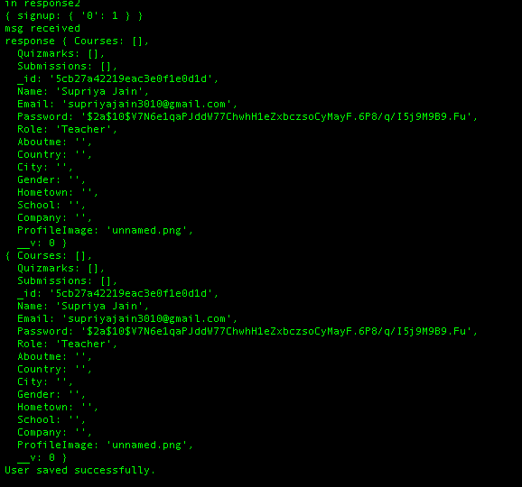

User already exists flow:

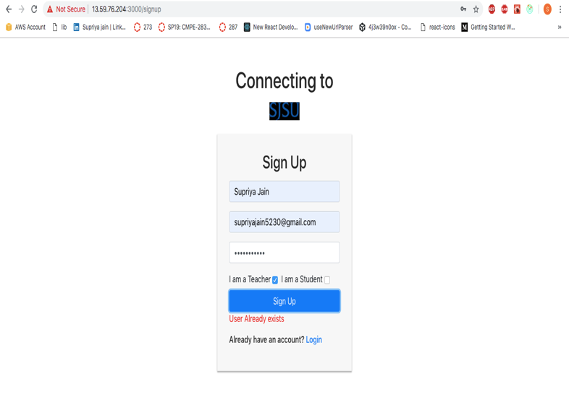

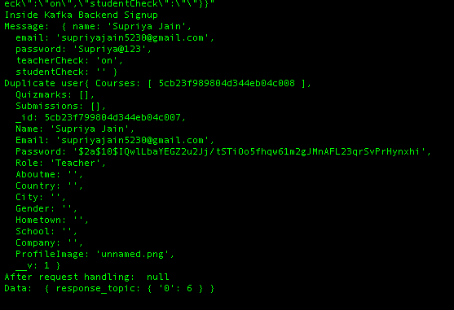

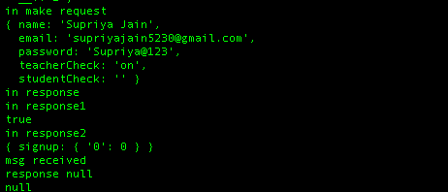

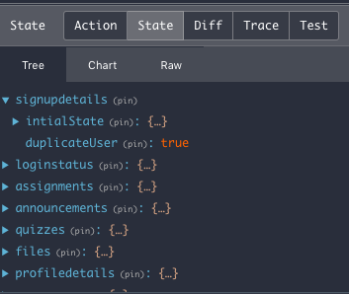

##### ***Profile Page for faculty and students:***

##### *User* can view and Edit profile data and profile picture.

To upload/change profile information, upload/change profile picture go to **Account** section of the side bar.

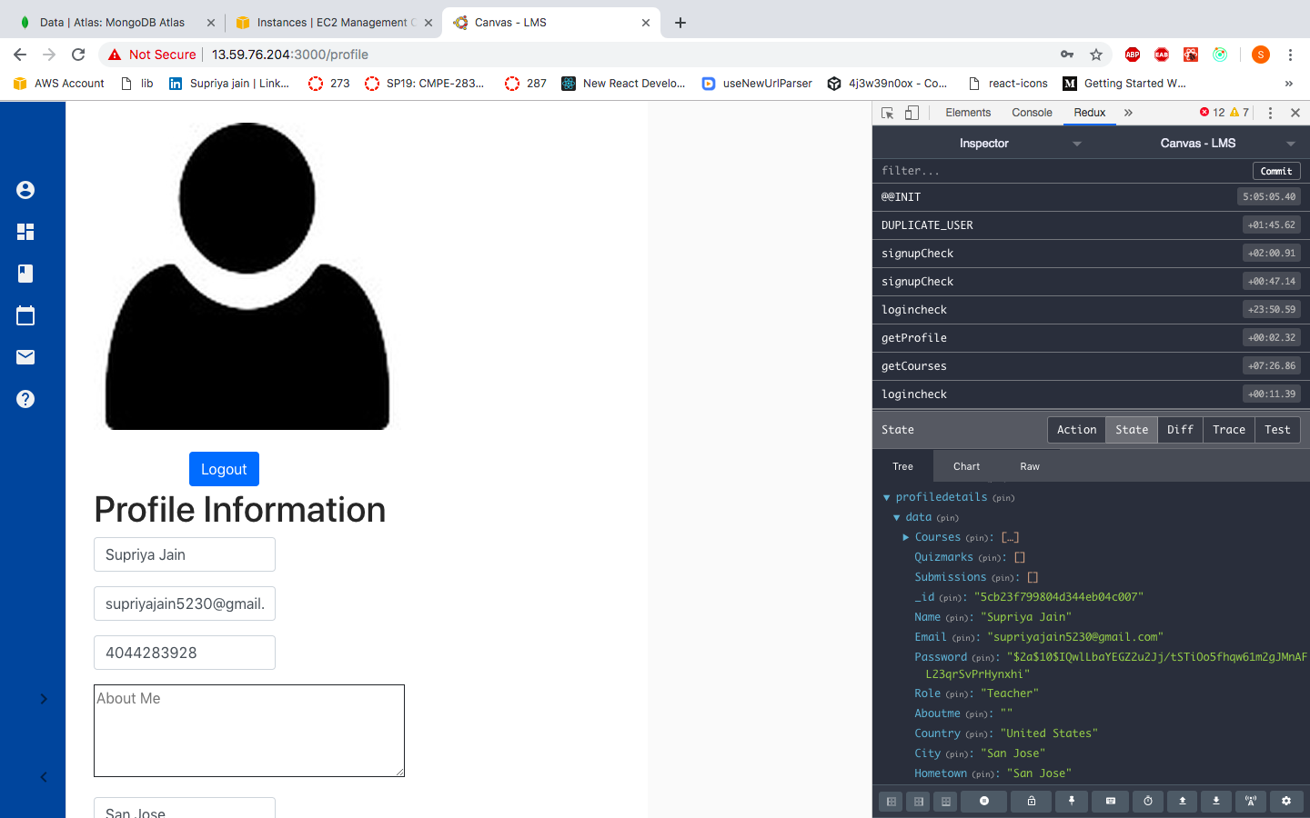

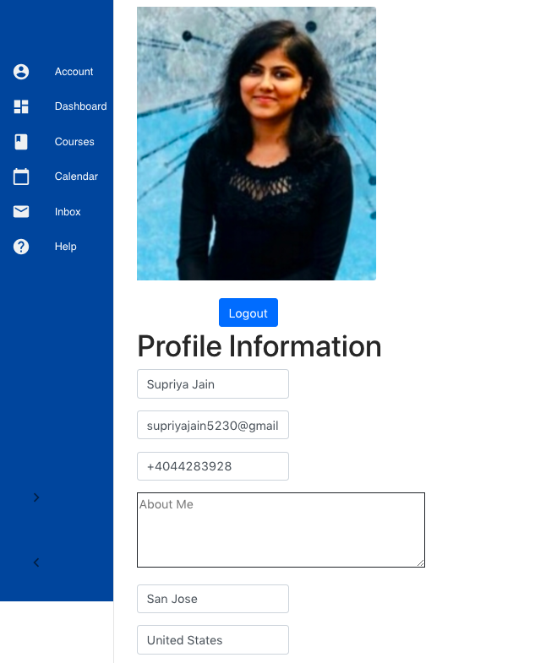

Update profile:

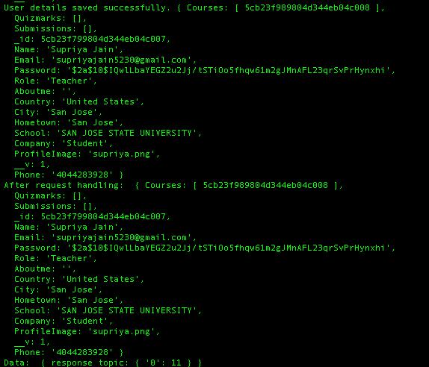

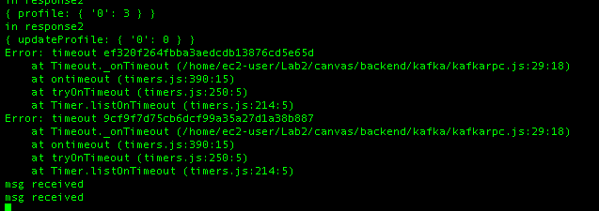

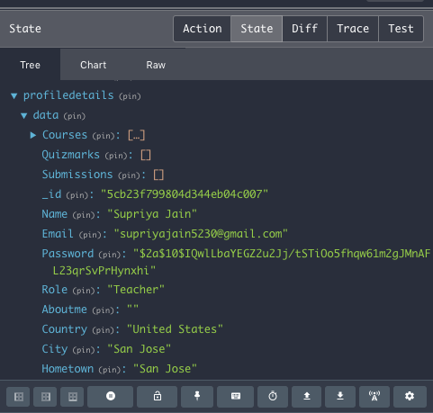

View Profile:

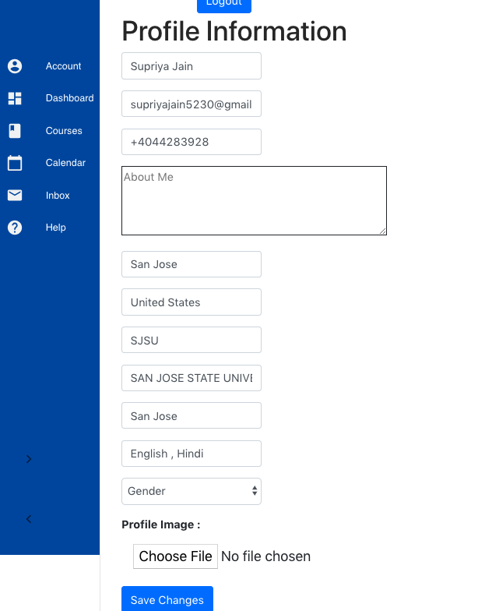

Redux and backend logs:

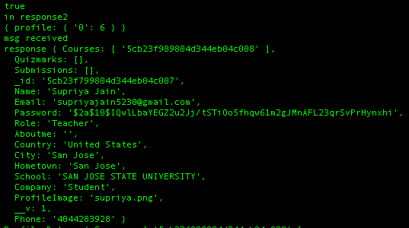

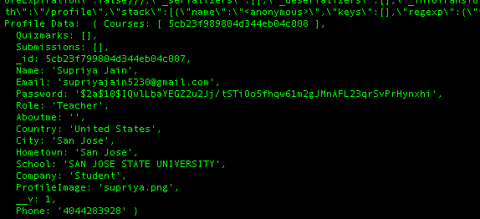

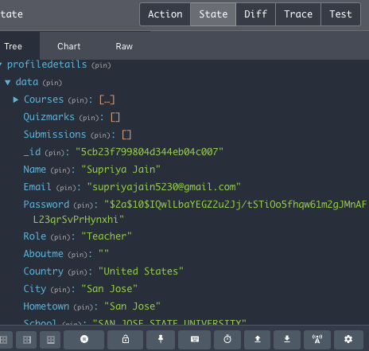

### Faculty Pages:

##### ***Faculty Dashboard Page:***

Faculty can create course. Faculty dashboard page will display courses created by faculty

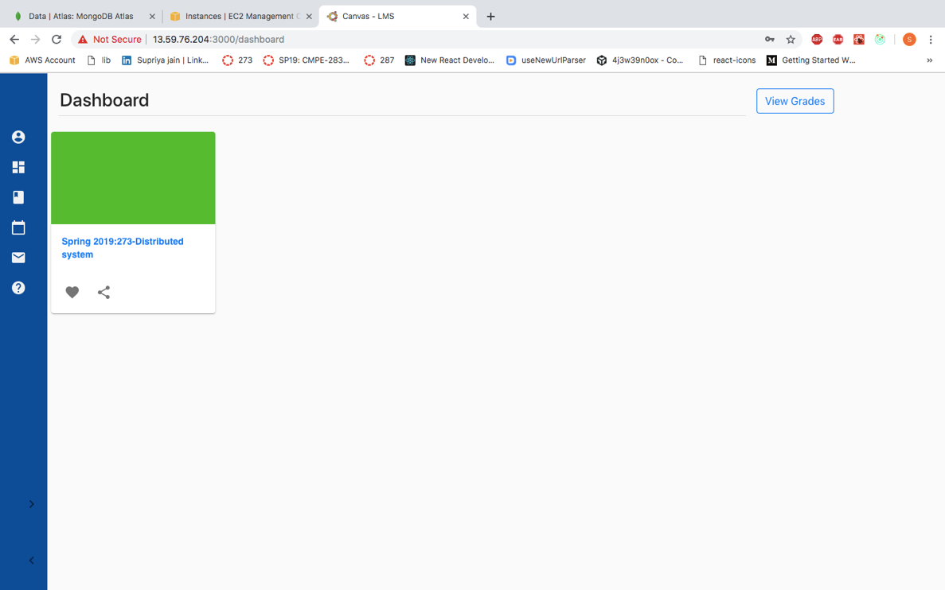

##### ***Faculty Course Page:* (Courses faculty will be taking in the current semester)**

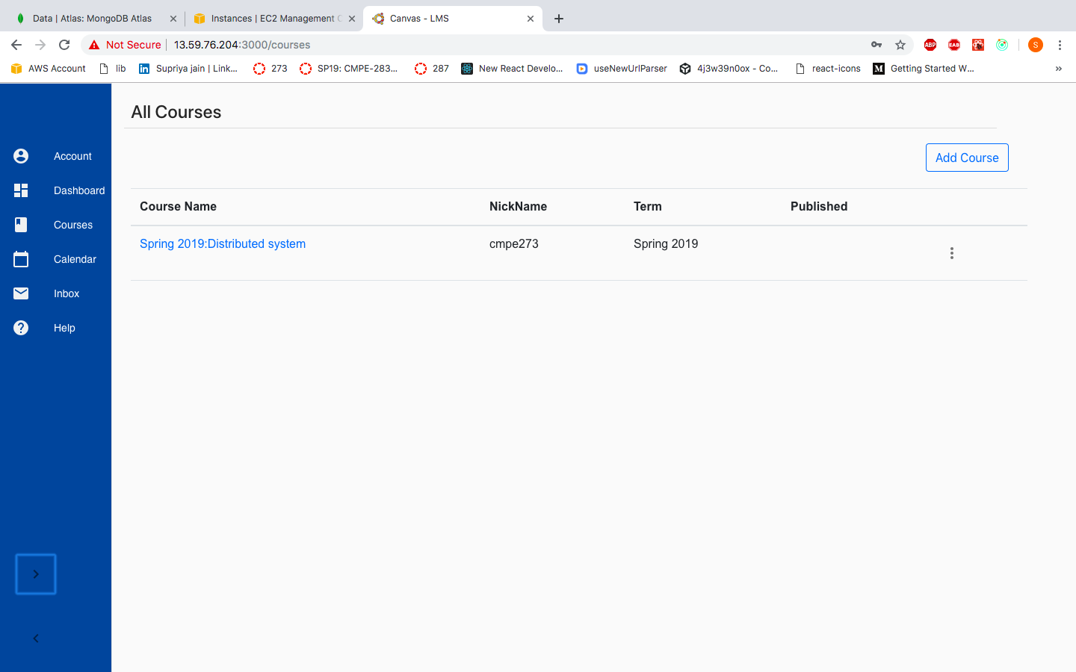

# 

##### ***Faculty AddCourse Page:***

##### 

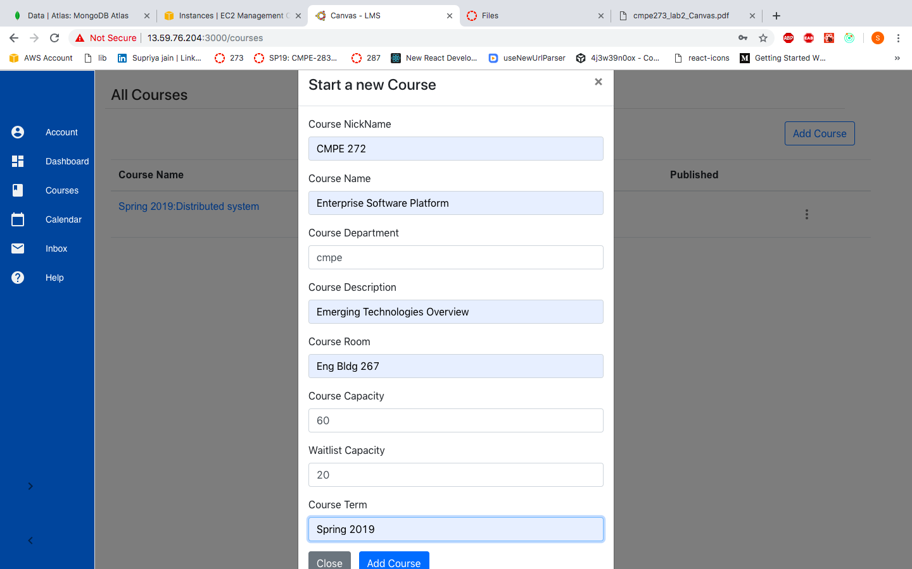

After adding course:

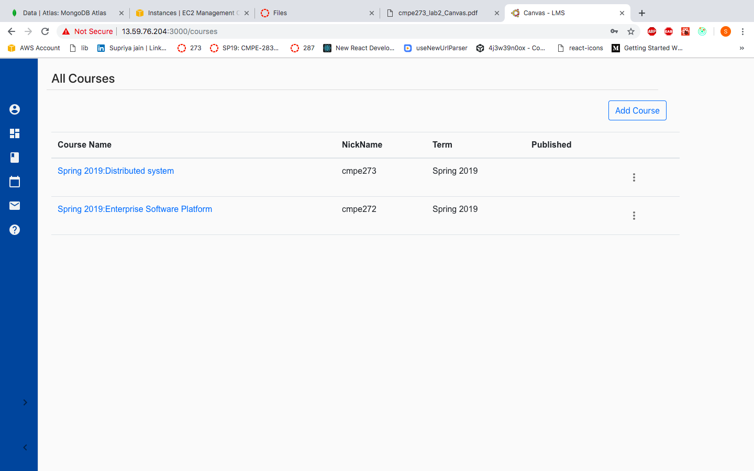

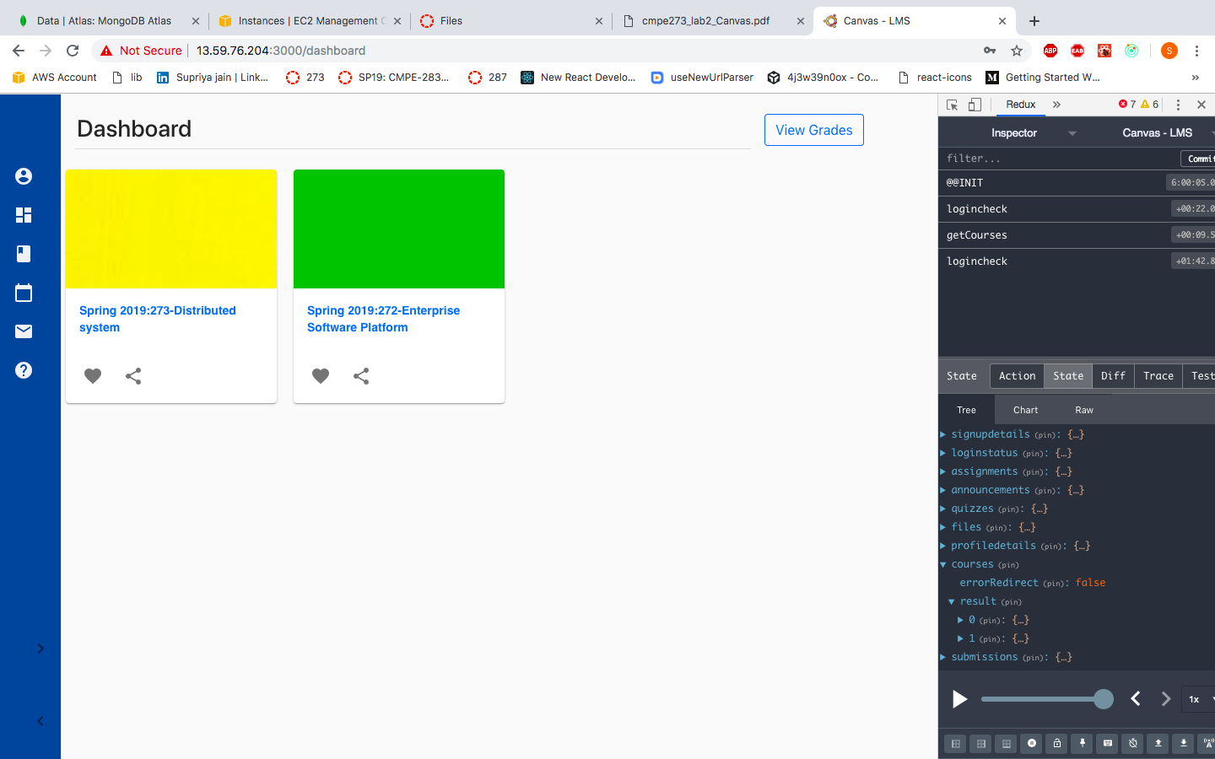

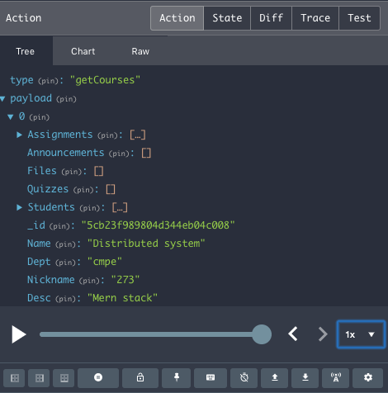

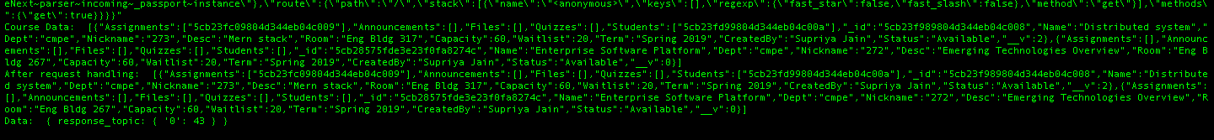

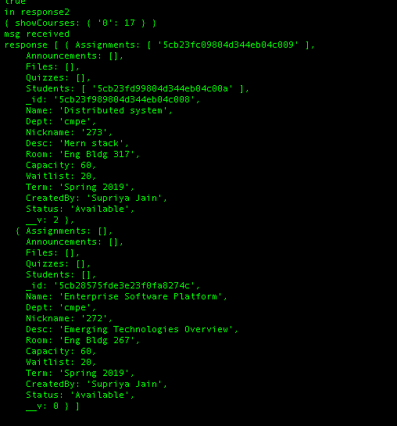

##### ***Faculty Create Assignment Page:***

Faculty can create assignment for the course. Set Due date and points for the assignment.

To create an assignment for the course,

1. Go to course page
2. Select the course for which you want to create an assignment
3. Click on Assignment from the menu list
4. Enter Assignment title, points in the text box. Enter assignment content/details in the HTML editor and select due date for the assignment from the date picker.

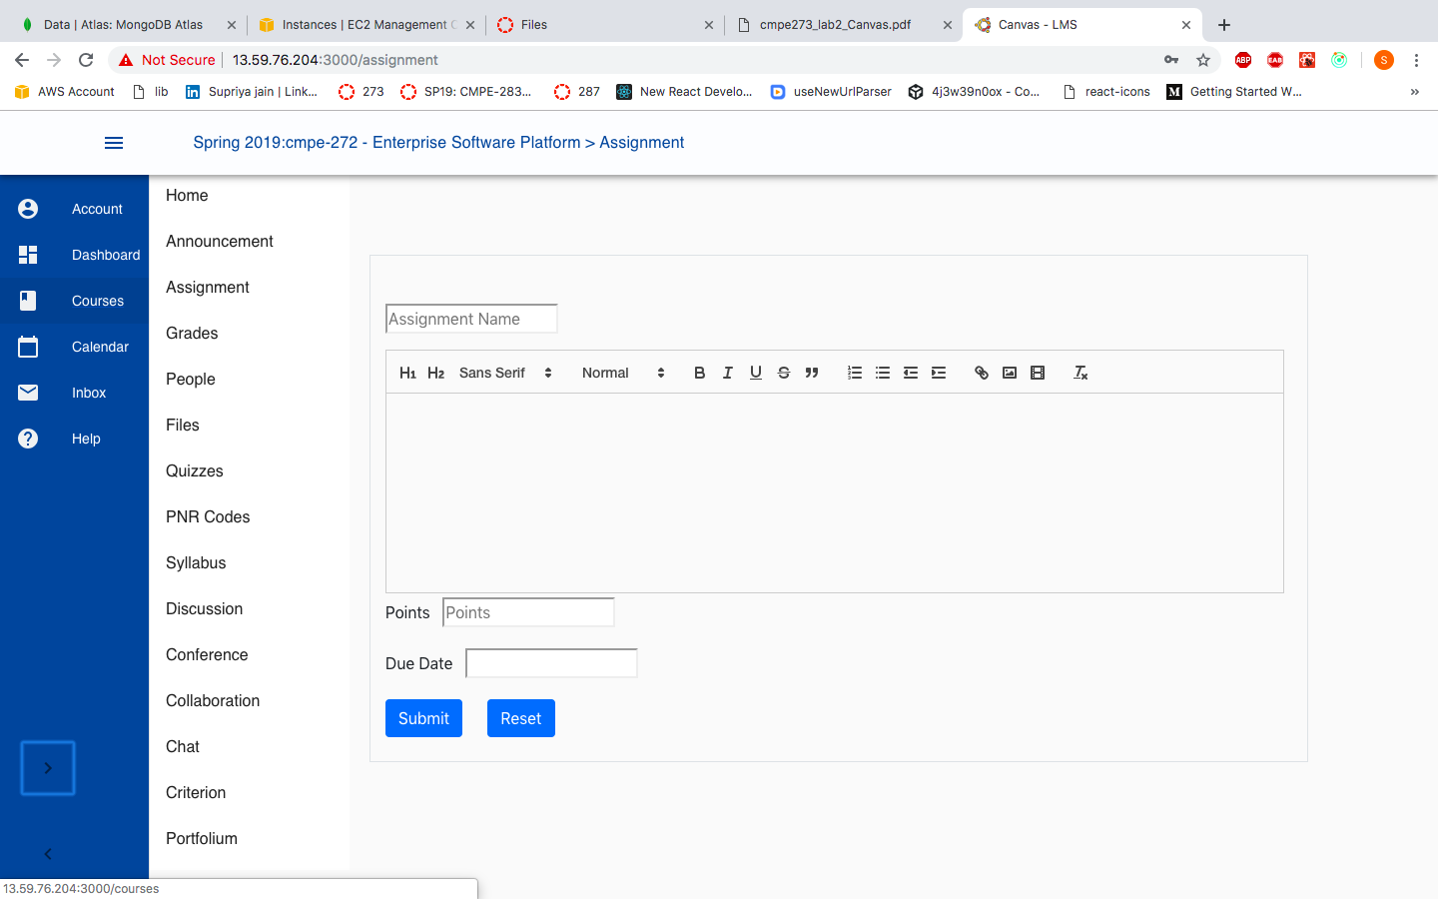

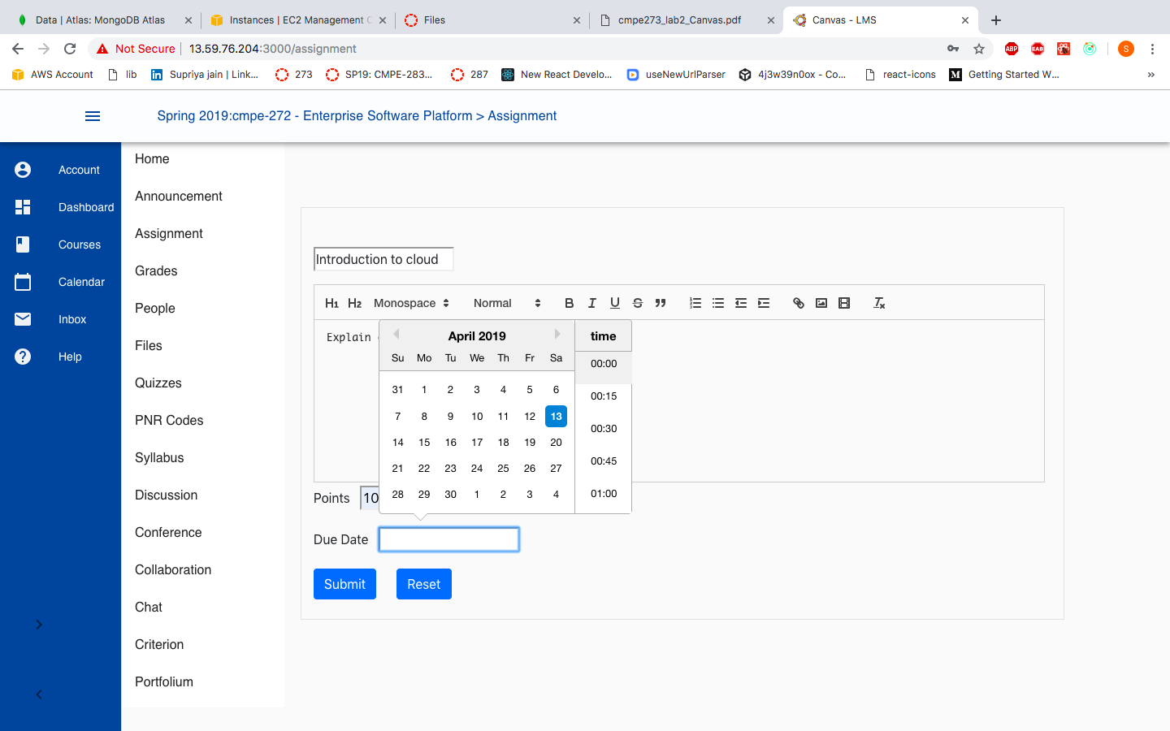

##### ***Faculty View Assignment Page:***

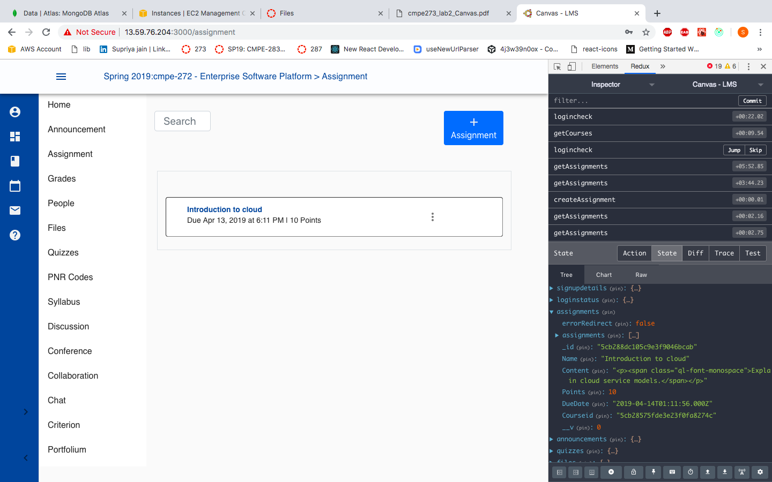

Backend flow:

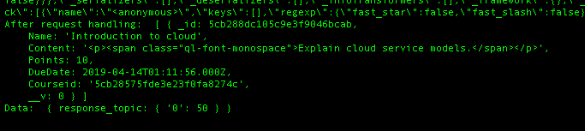

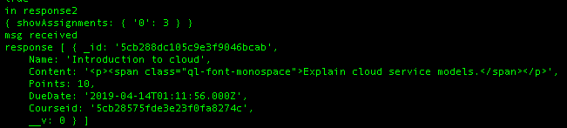

Redux screenshots for view assignments:

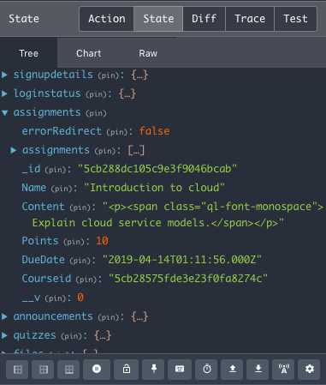

##### ***Faculty Can Edit and Delete already created Assignments:***

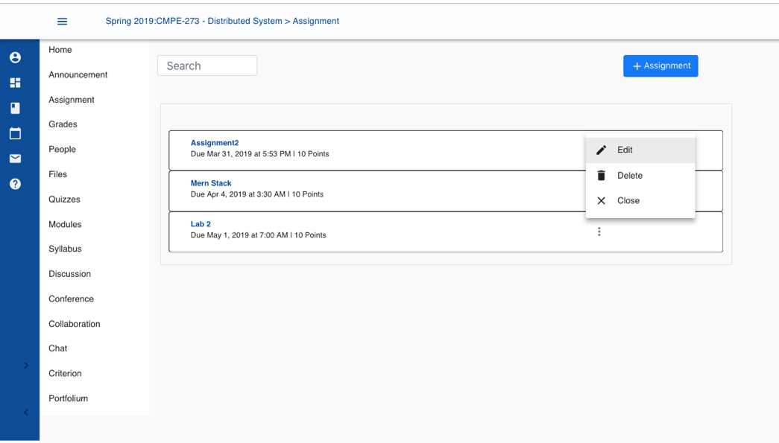

##### ***Faculty Create Announcements Page:***

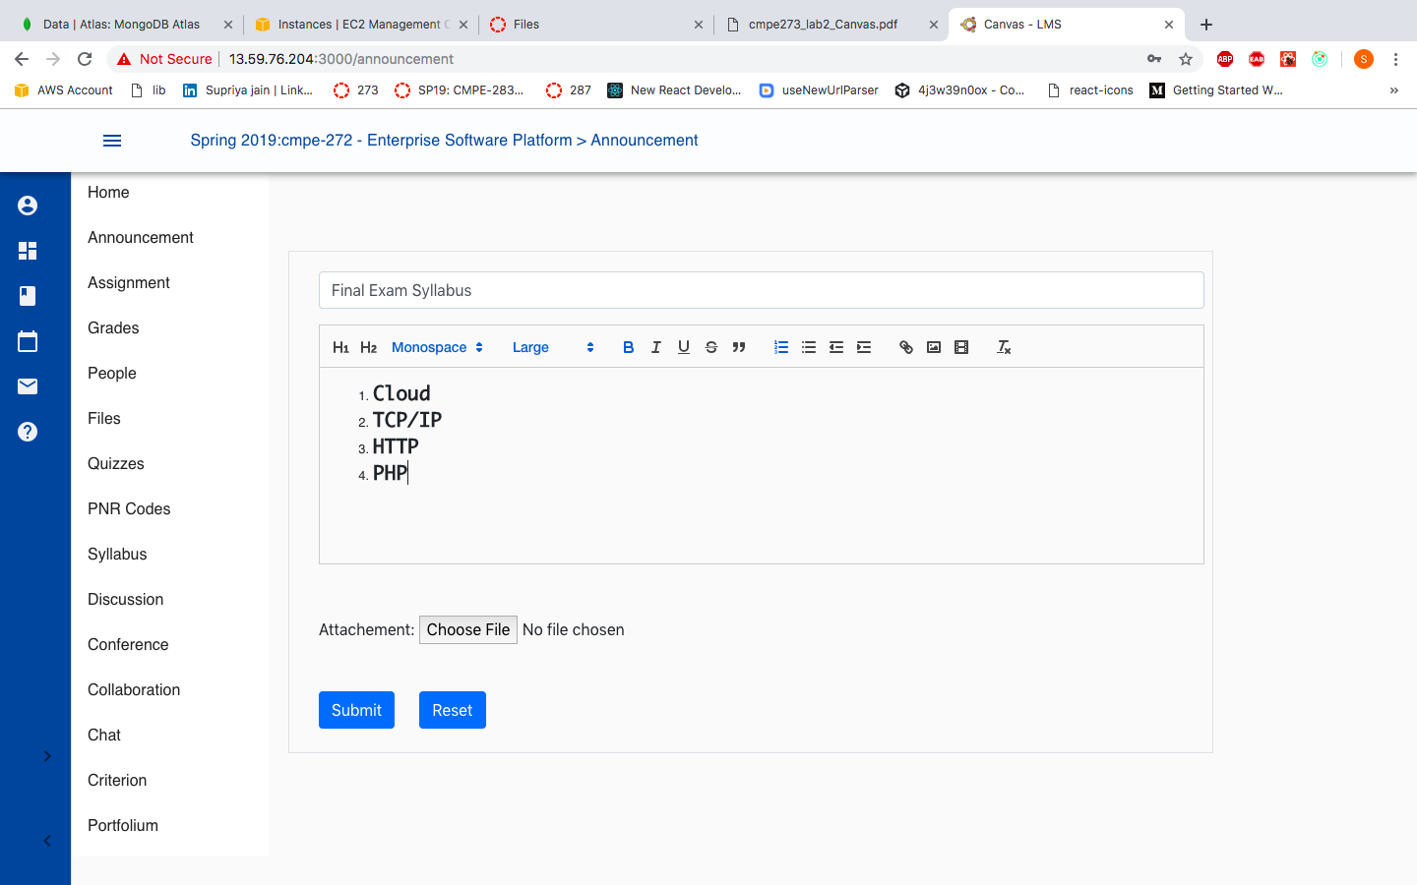

##### ***Faculty View Announcements Page:***

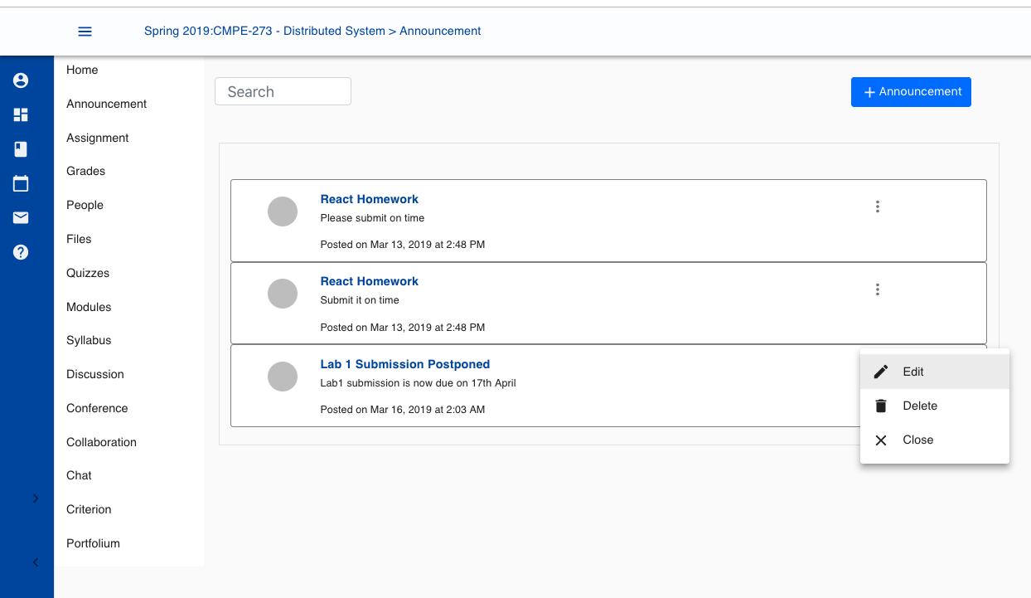

##### ***Faculty Can Edit and Delete already created Announcements:***

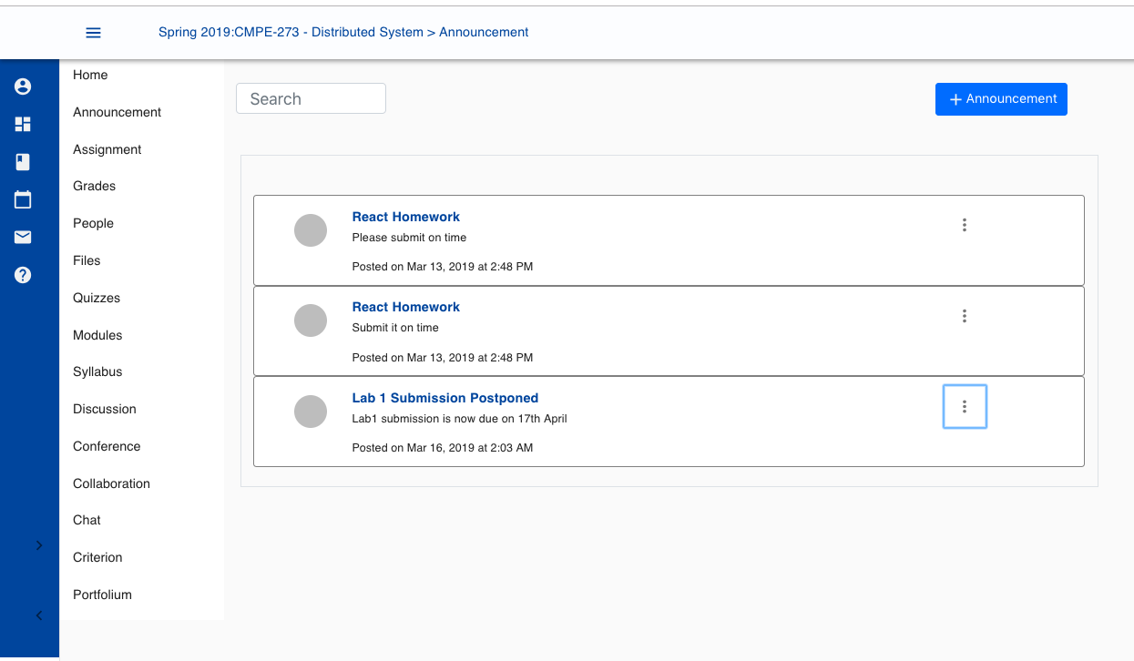

#### **Faculty: View Enrolled Student for the courses**

**

Producer logs for people:

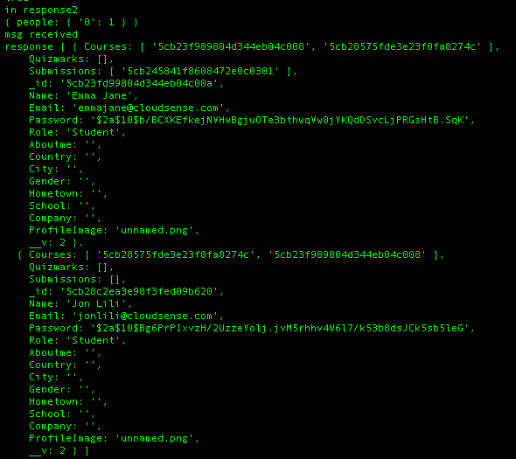

Consumer logs for people:

|  |
| --- |
| message recieved for people [object Object] Courses":["5cb23f989804d344eb04c008","5cb28575fde3e23f0fa8274c"],"Quizmarks":[],"Submissions":["5cb245841f8608472e0c0301"],"_id":"5cb23fd99804d344eb04c00a","Name":"Emma Jane","Email":"emmajane@cloudsense.com","Password":"$2a$10$b/BCXKEfkejNVHwBgjuOTe3bthwqVw0jYKQdDSvcLjPRGsHtB.SqK","Role":"Student","Aboutme":"","Country":"","City":"","Gender":"","Hometown":"","School":"","Company":"","ProfileImage":"unnamed.png","__v":2},{"Courses":["5cb28575fde3e23f0fa8274c","5cb23f989804d344eb04c008"],"Quizmarks":[],"Submissions":[],"_id":"5cb28c2ea3e98f3fed09b620","Name":"Jon Lili","Email":"jonlili@cloudsense.com","Password":"$2a$10$Bg6PrPIxvzH/2UzzeYolj.jvM5rhhv4W6l7/k53b8dsJCk5sb5leG","Role":"Student","Aboutme":"","Country":"","City":"","Gender":"","Hometown":"","School":"","Company":"","ProfileImage":"unnamed.png","__v":2}] Data: { response_topic: { '0': 71 } } |

#### **Faculty: Remove Student from the courses**

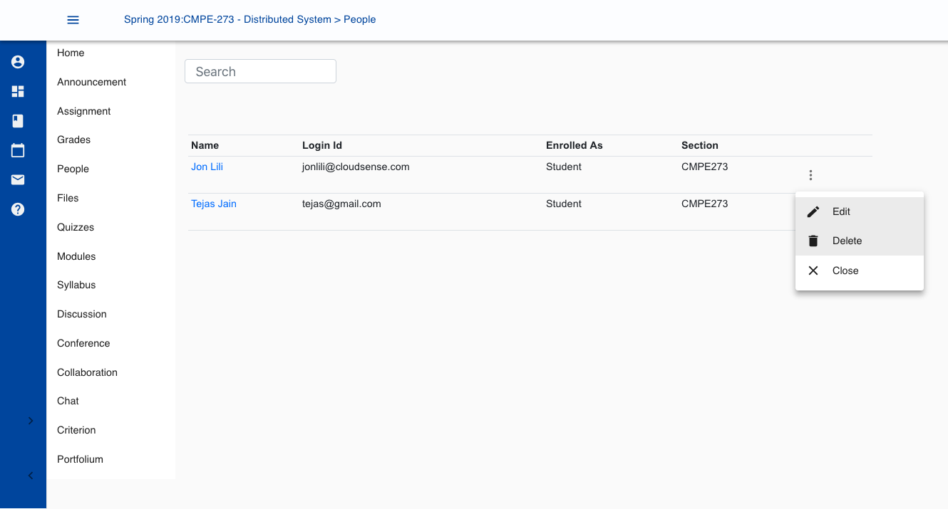

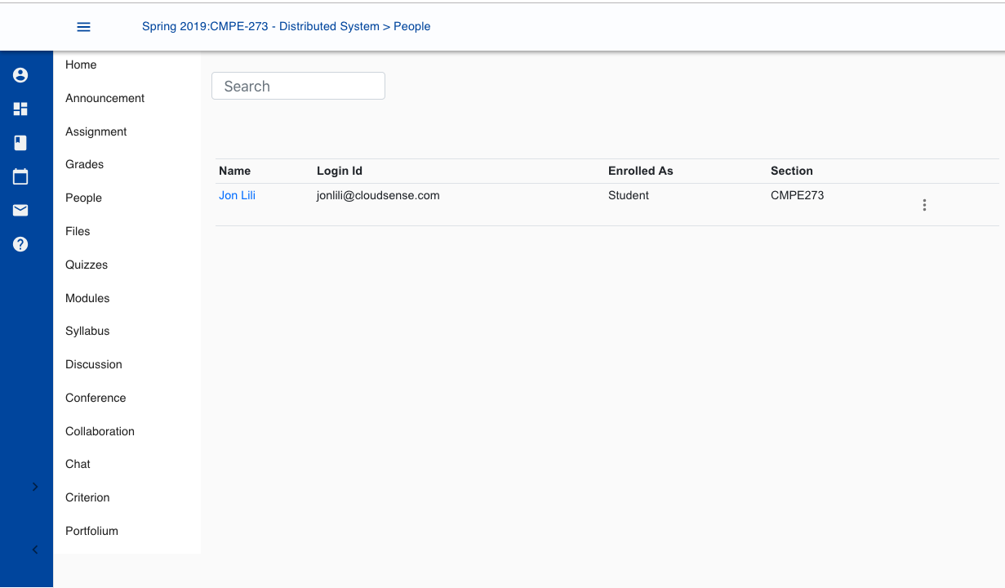

#### **Faculty: View/Upload Lecture Files and Notes:**

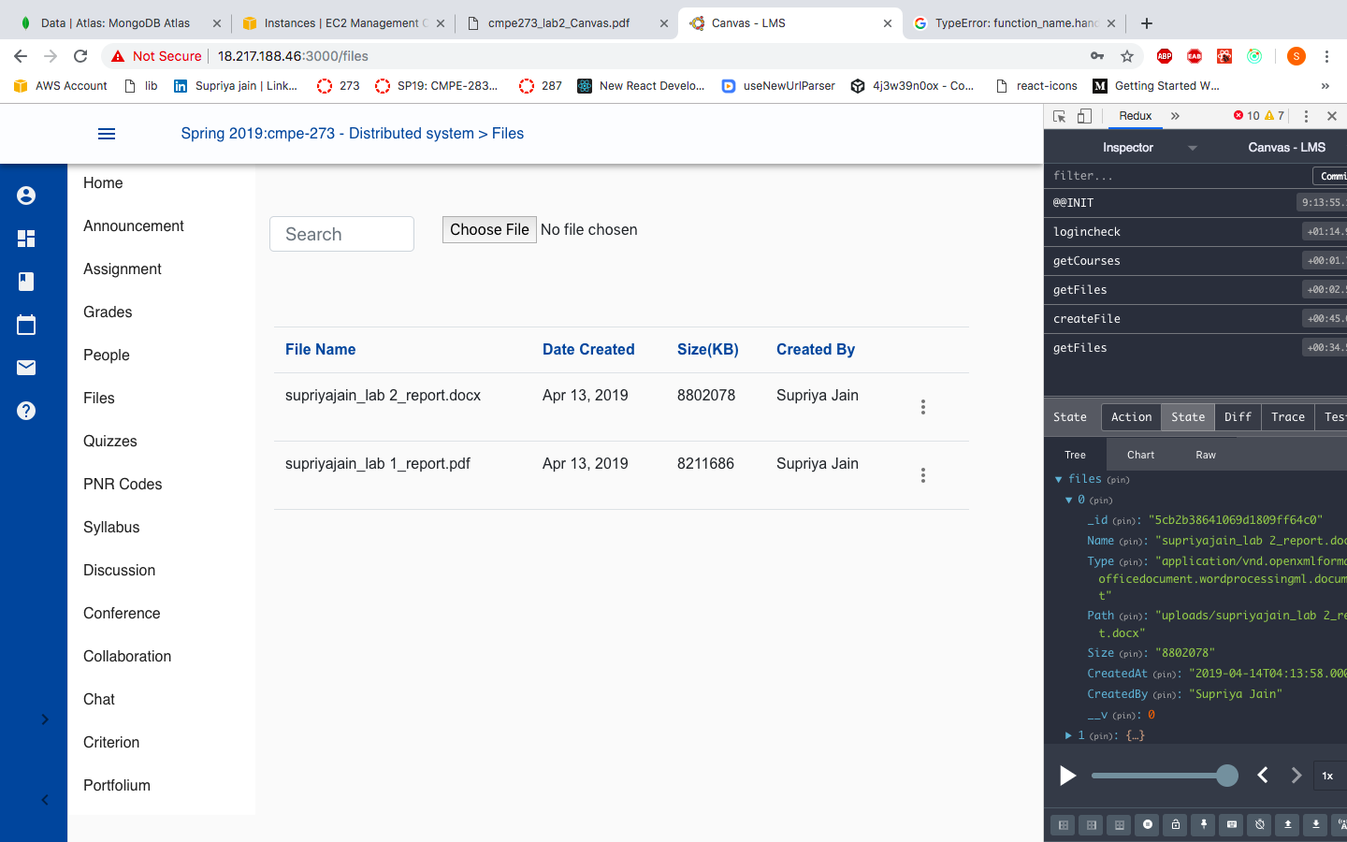

Producer logs – View Files:

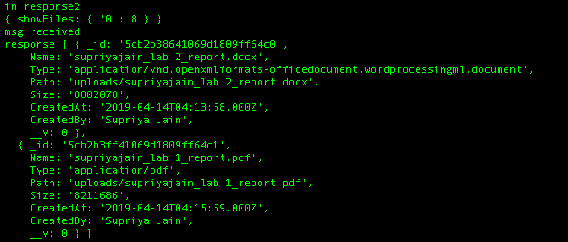

Consumer logs – View Files:

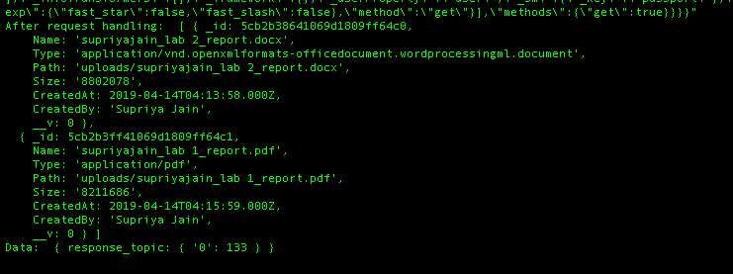

Redux: View Files

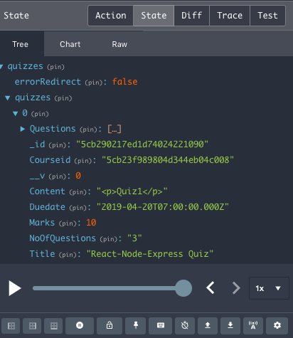

To Upload file/files:

1. Click on the Files tab from the menu-list.
2. Click on choose file and select file from the local machine
3. After you click on OK files will be uploaded to the server.

Producer logs – Add File:

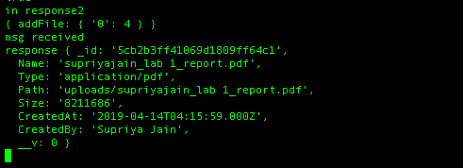

Consumer logs – Add File:

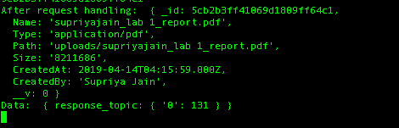

#### **Faculty: Create Quiz**

Create a quiz by clicking on Details tab

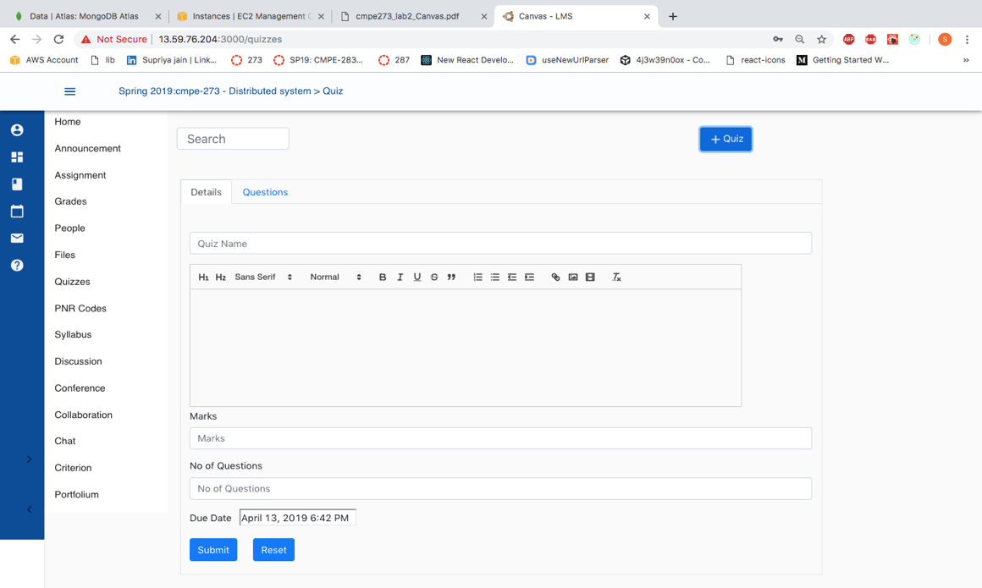

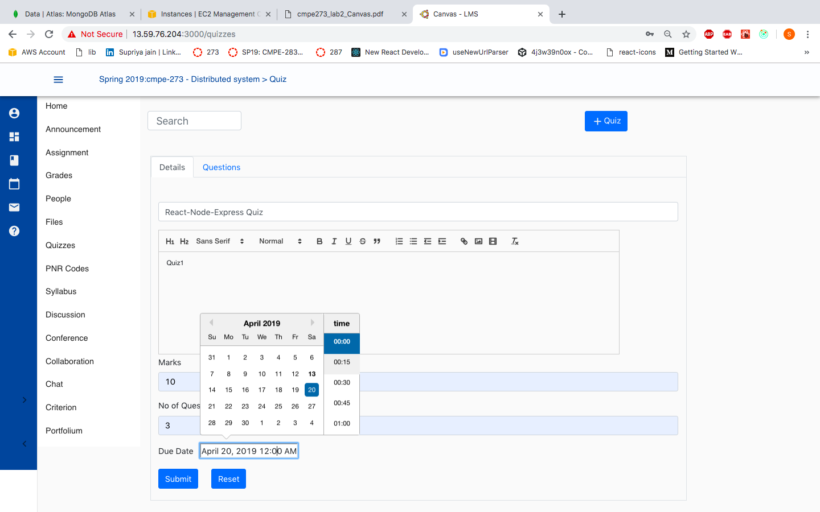

Create Quiz Questions by clicking on Questions tab

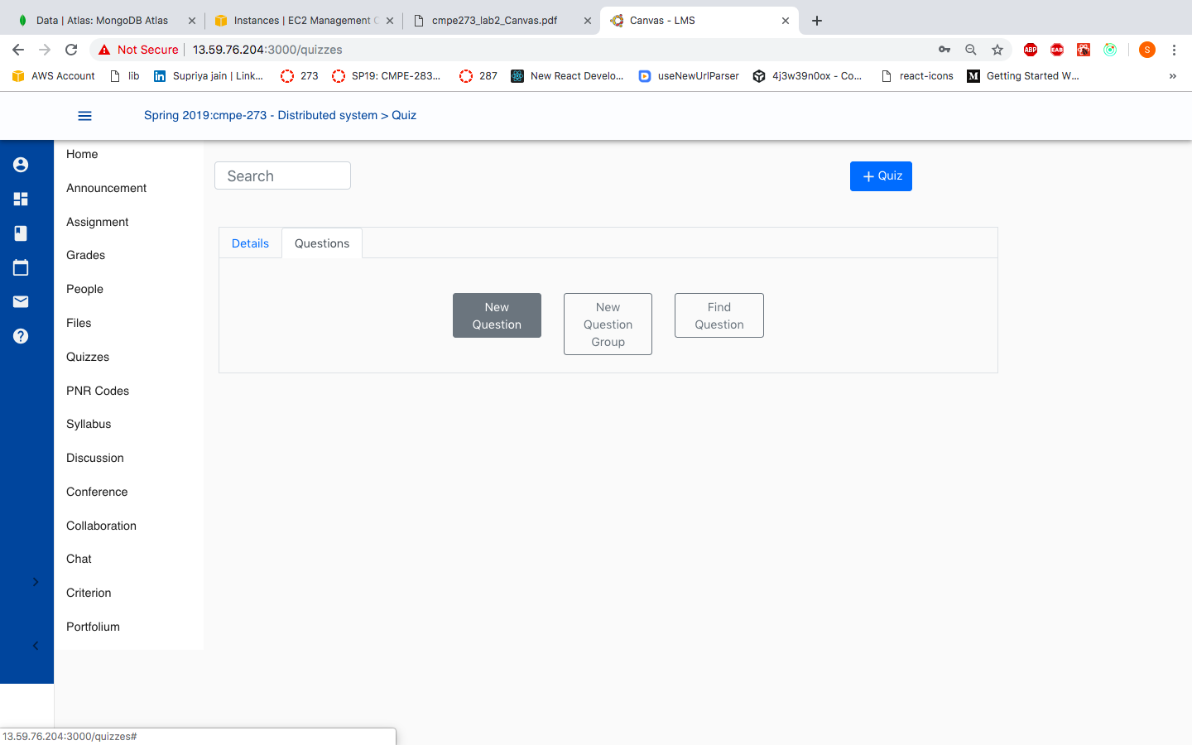

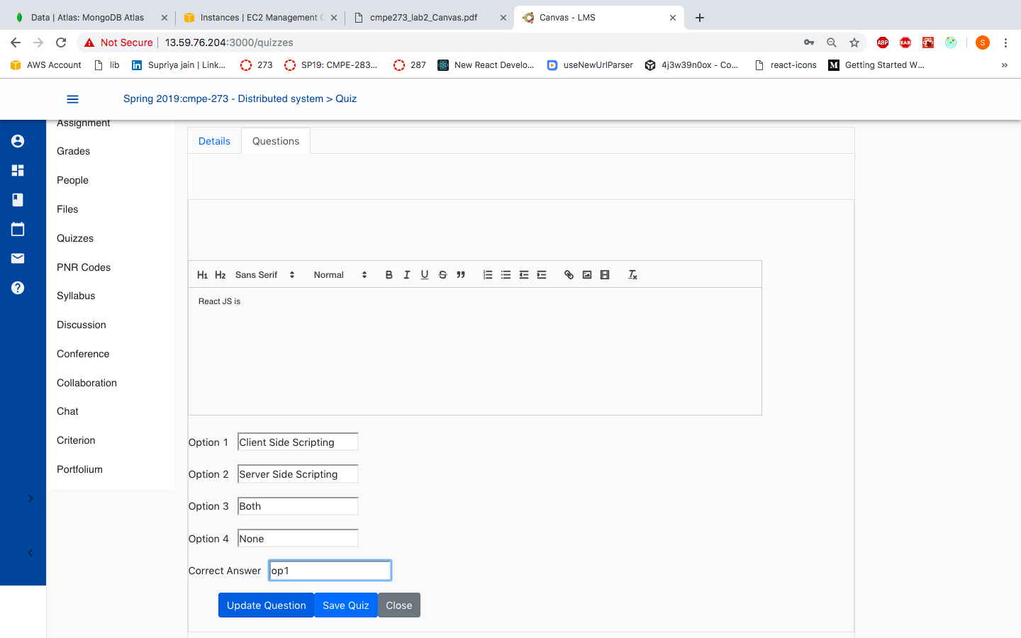

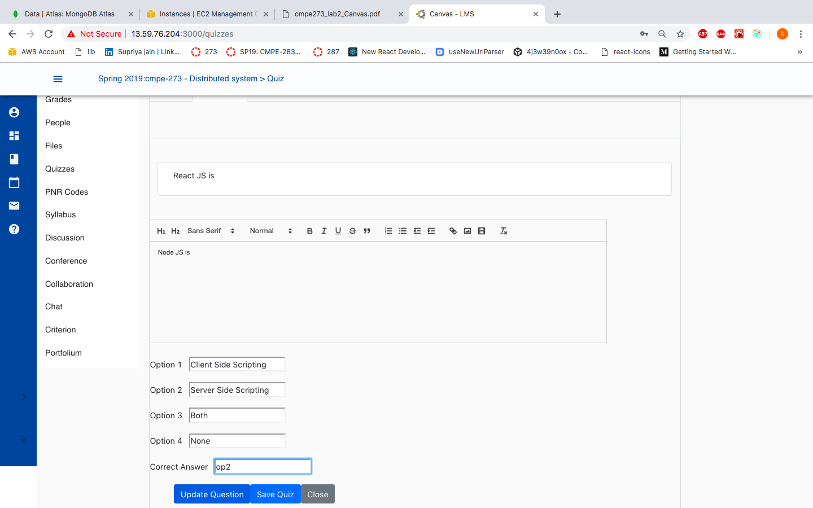

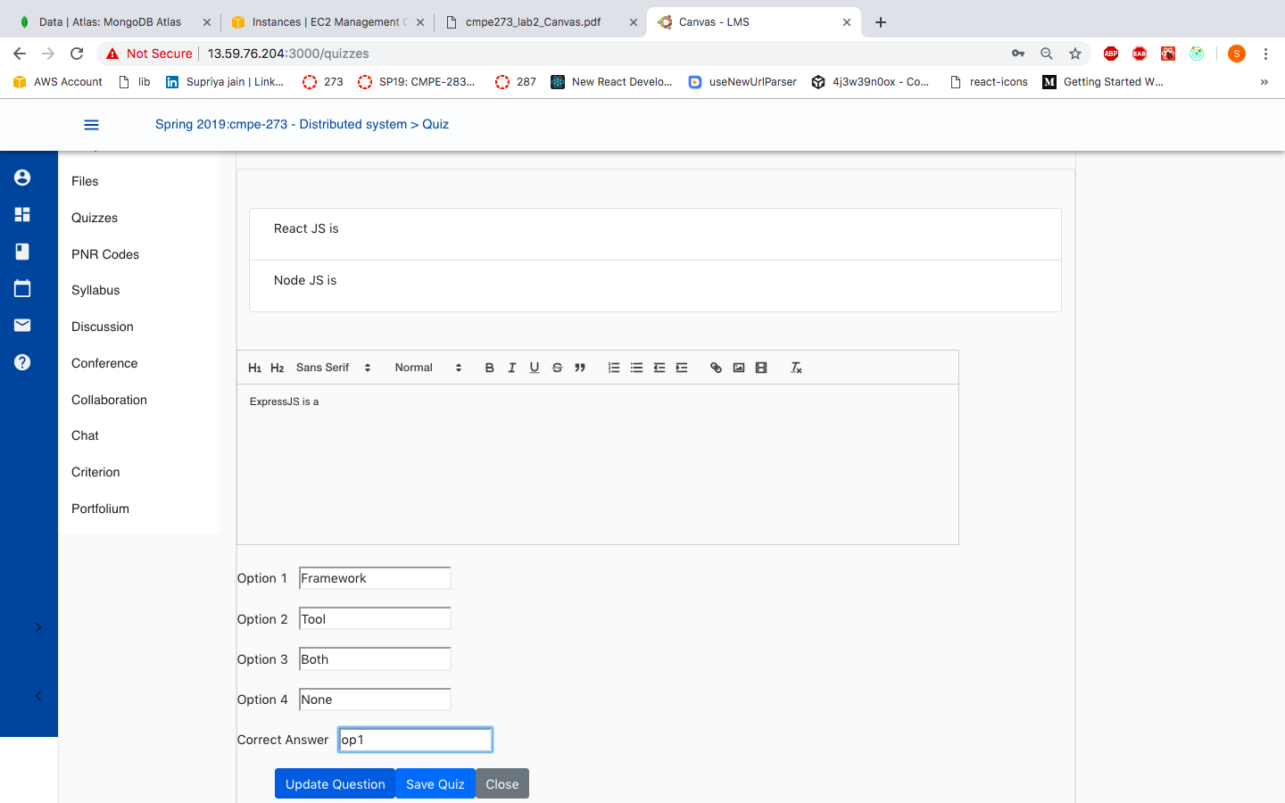

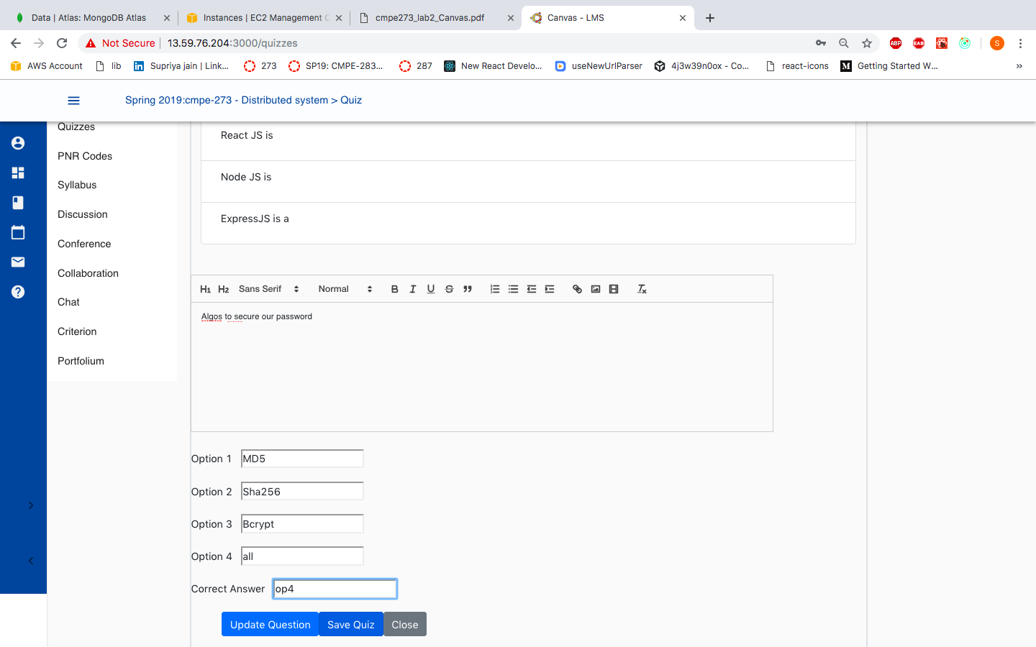

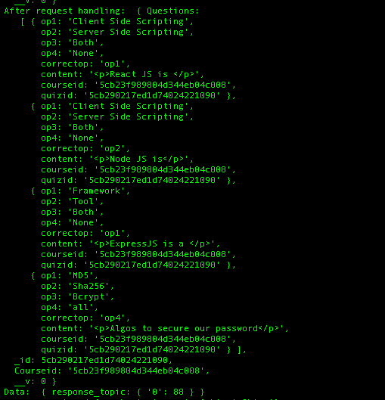

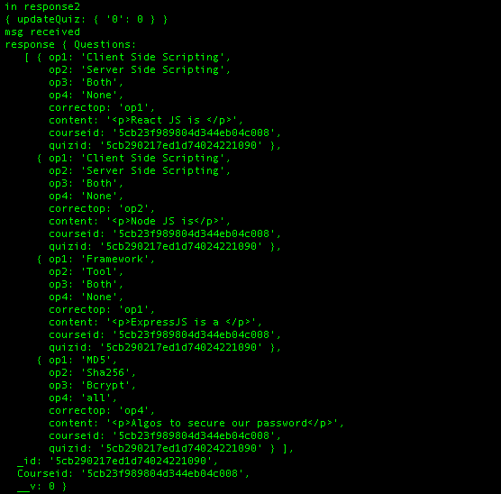

#### **Faculty: View Quizzes**

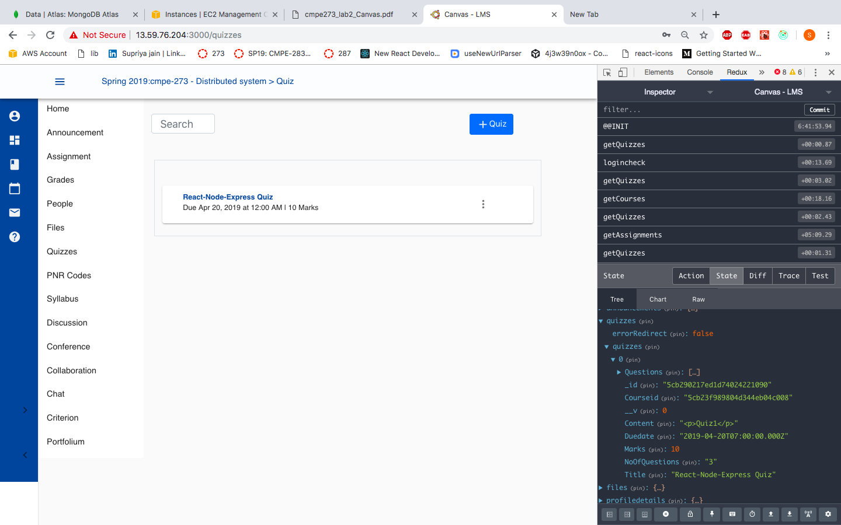

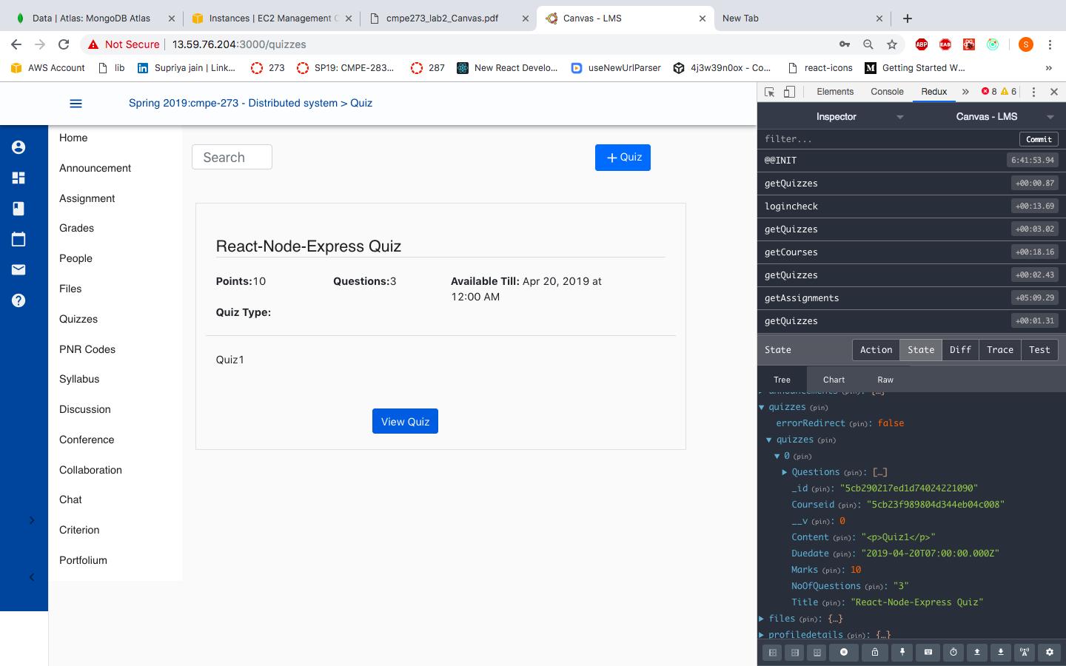

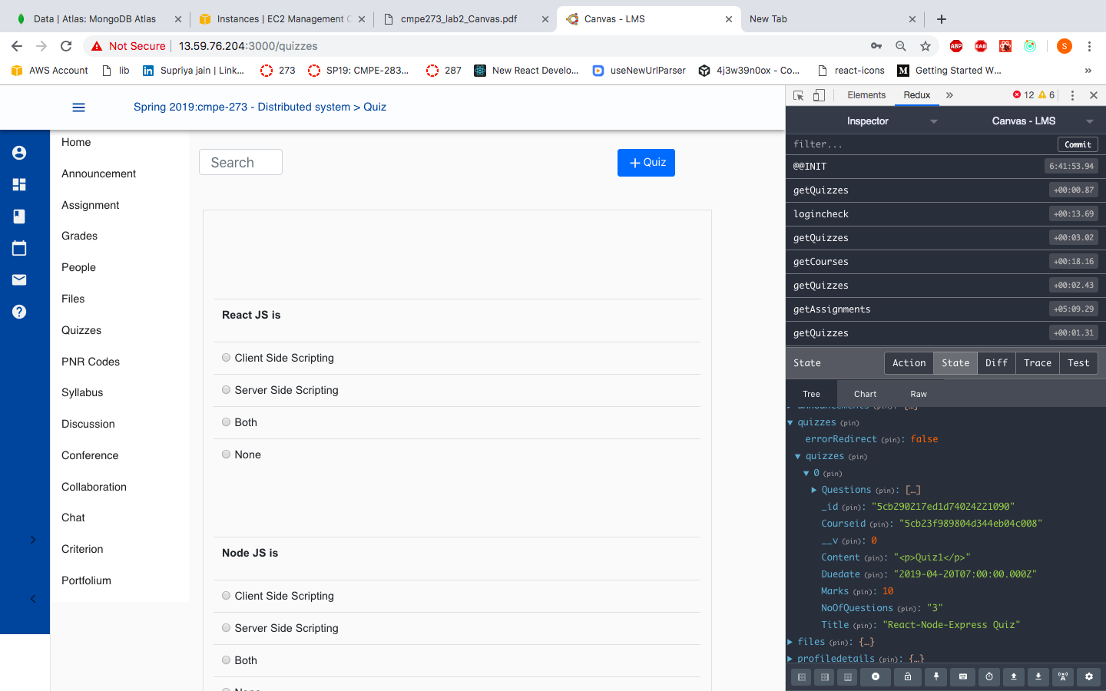

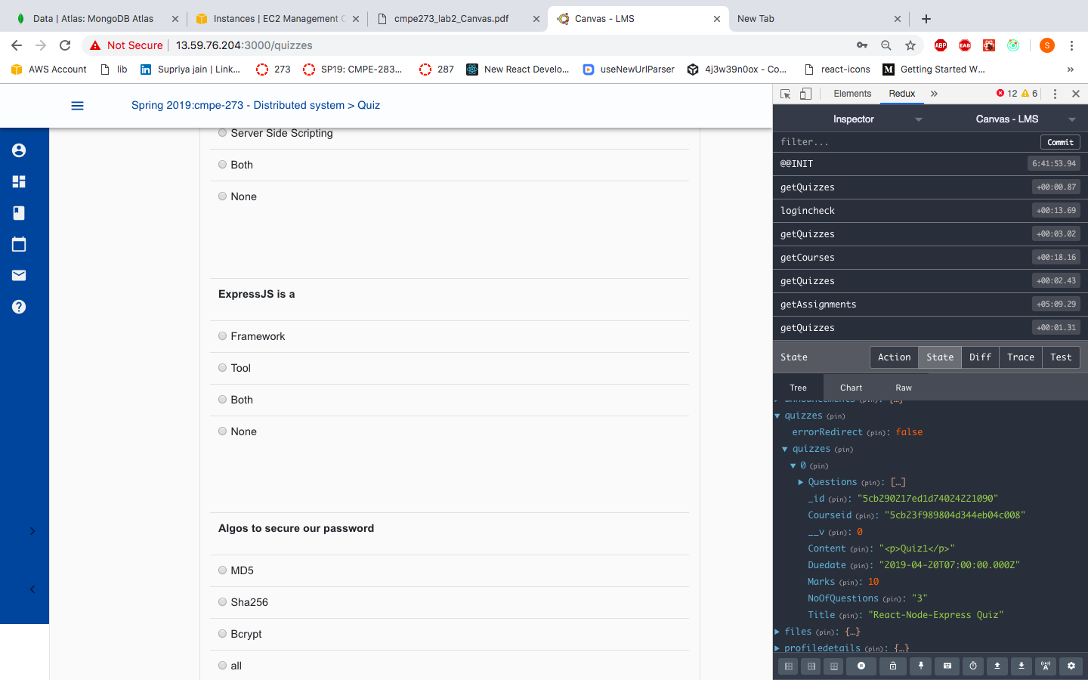

Kafka Producer logs:

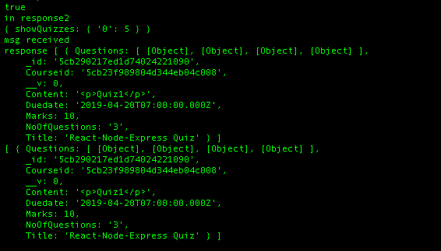

Kafka consumer log:

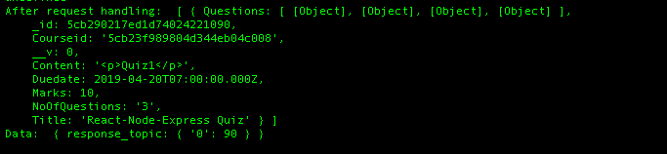

Redux:

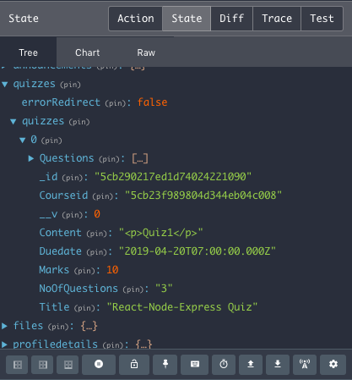

#### **Faculty: Permission Number**

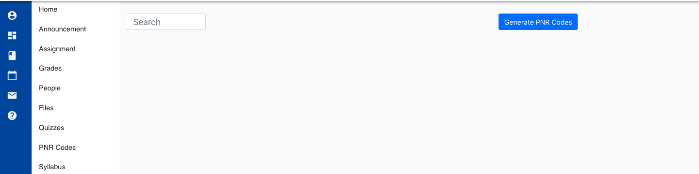

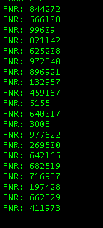

#### **Faculty Grade Assignment:**

Faculty can see assignment submitted by students by clicking on “Grade Assignment” button

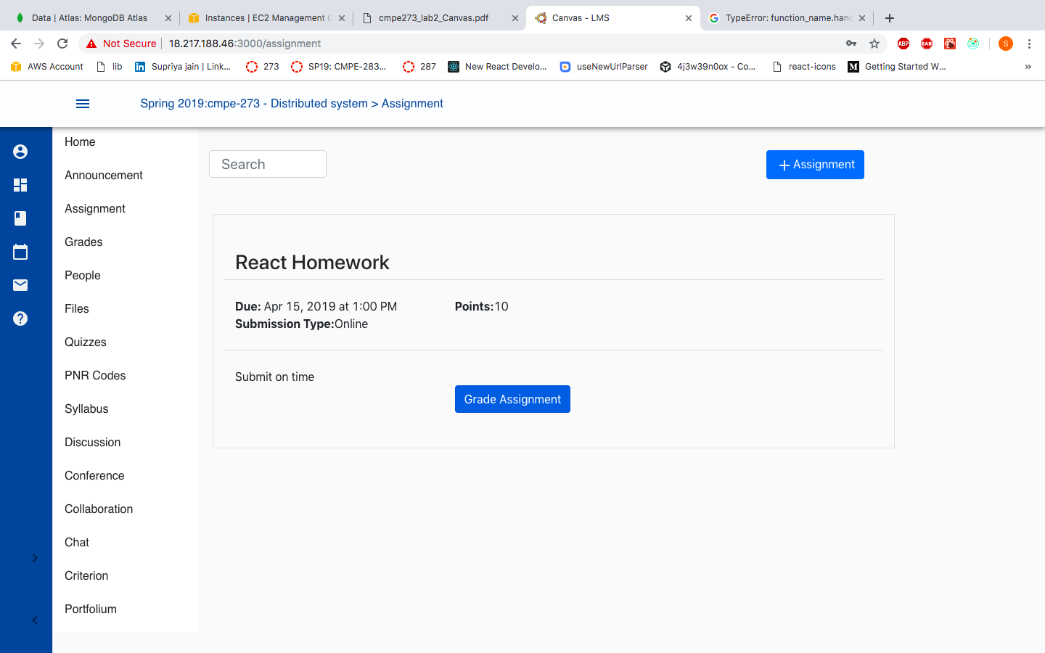

He/She can see all the submissions for that particular assignment from all the students enrolled in that course.

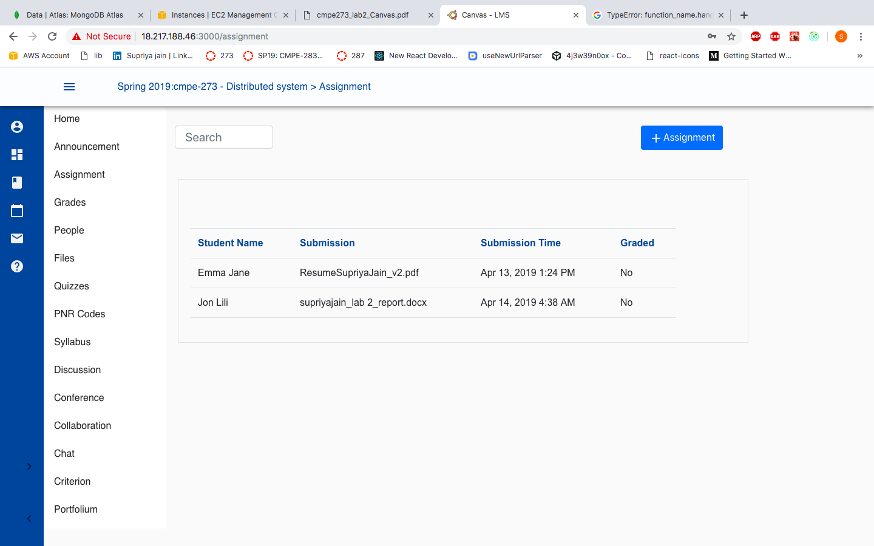

Faculty will grade the student submission by giving marks in the text box.

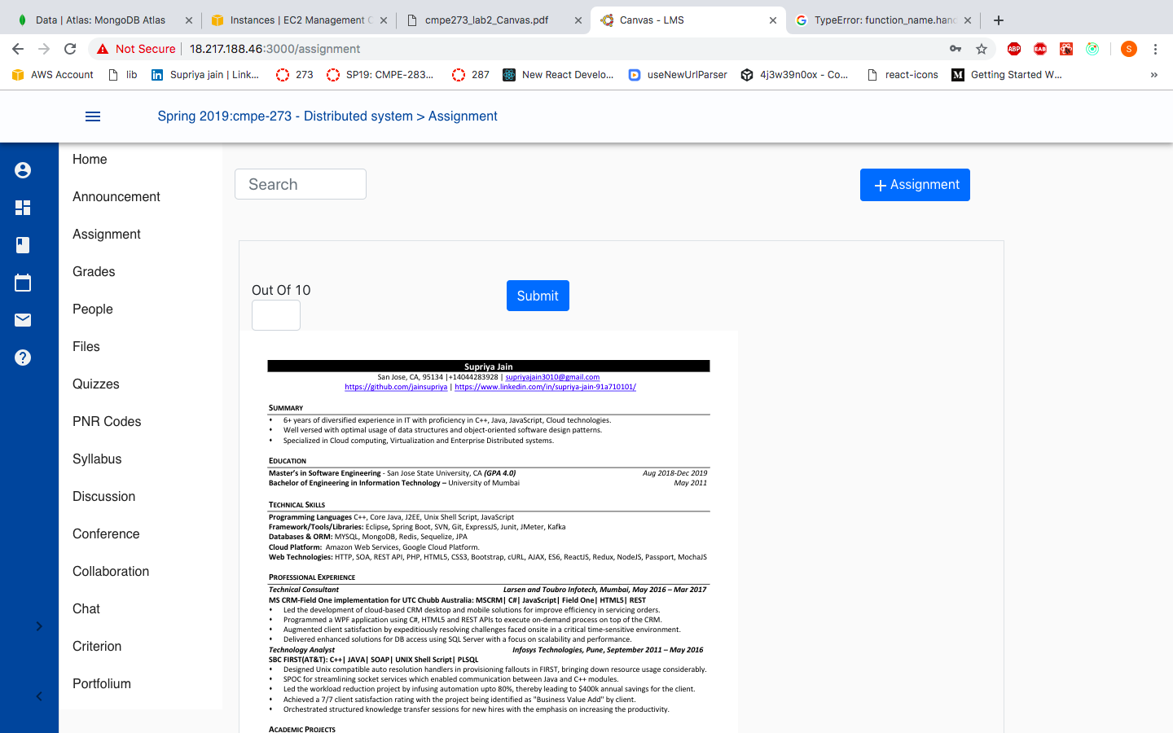

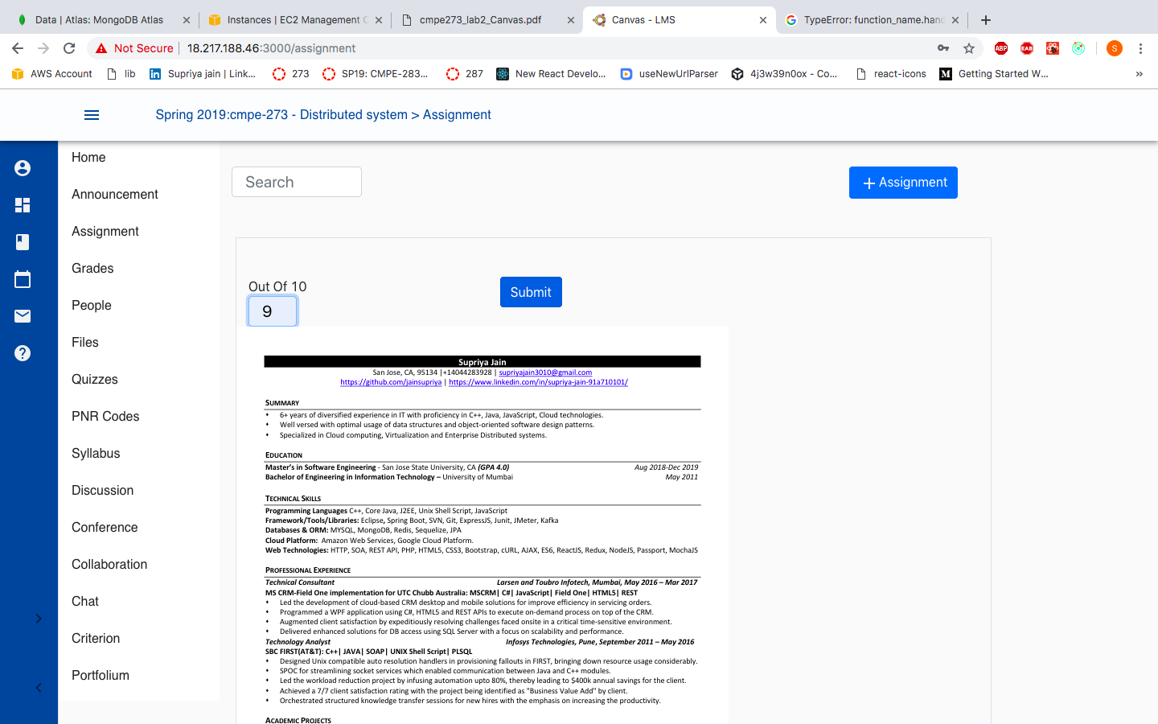

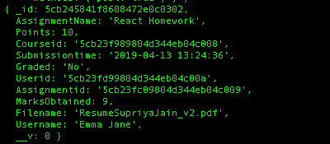

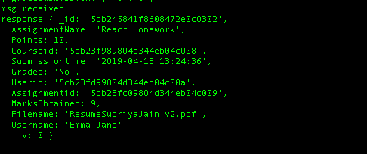

#### **Student: Dashboard**

Student can see courses enrolled by them on dashboard page. Click on Dashboard tab from the leftmost vertical menu drawer.

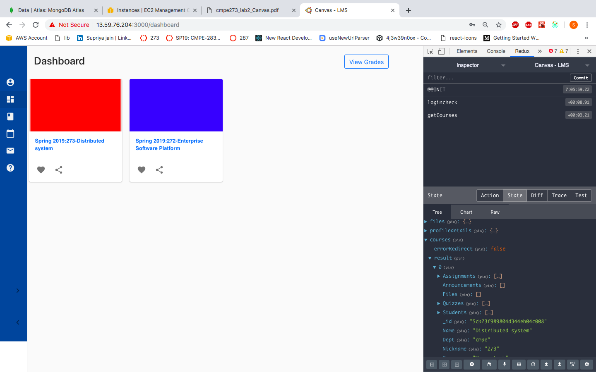

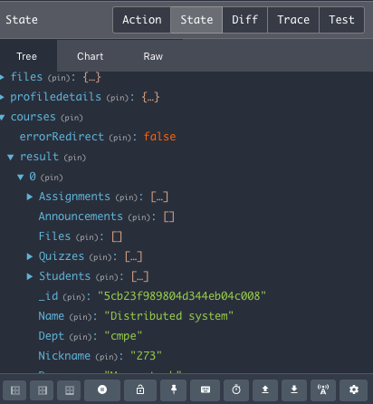

Producer logs:

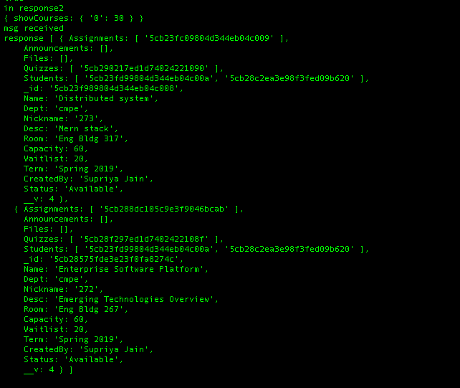

Consumer logs:

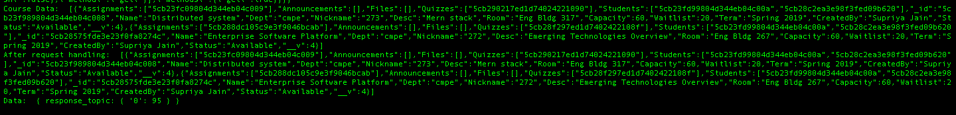

#### **Student: Profile :**

Same as faculty profile page. Screenshots attached at the beginning.

#### **Student: View Announcement**

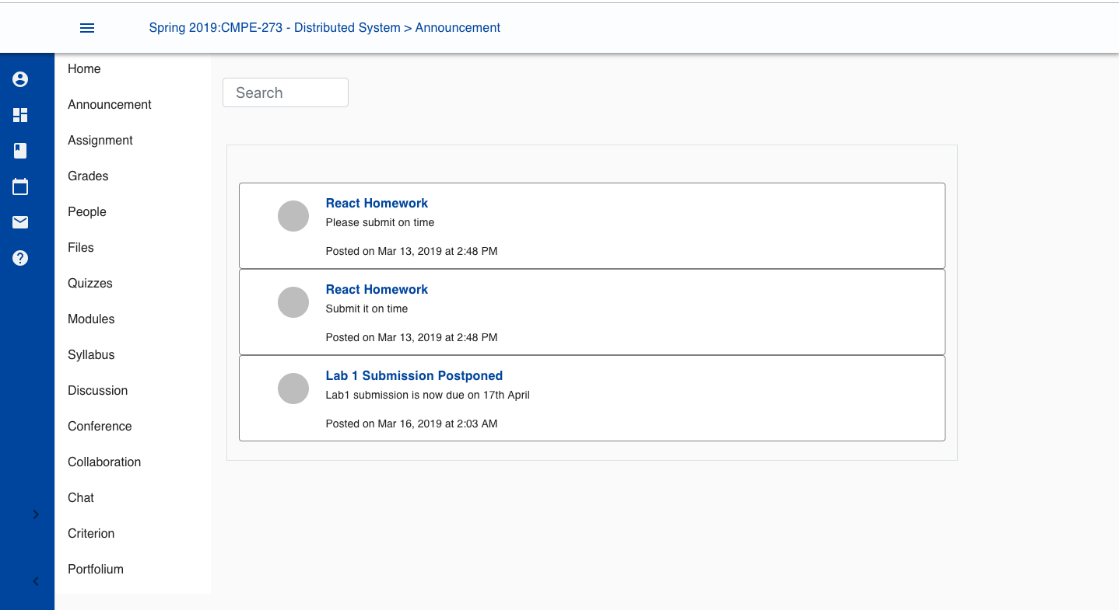

#### **Student: View Announcement**

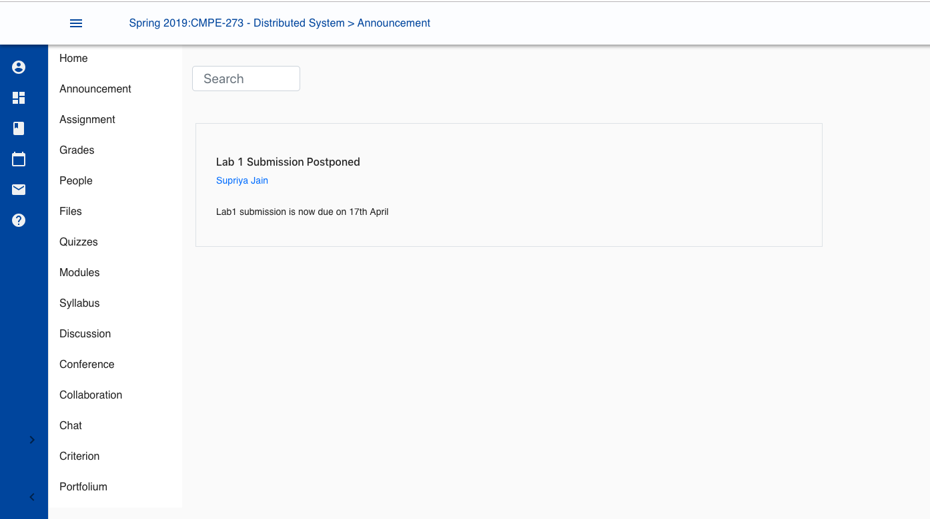

#### **Student: View Assignment**

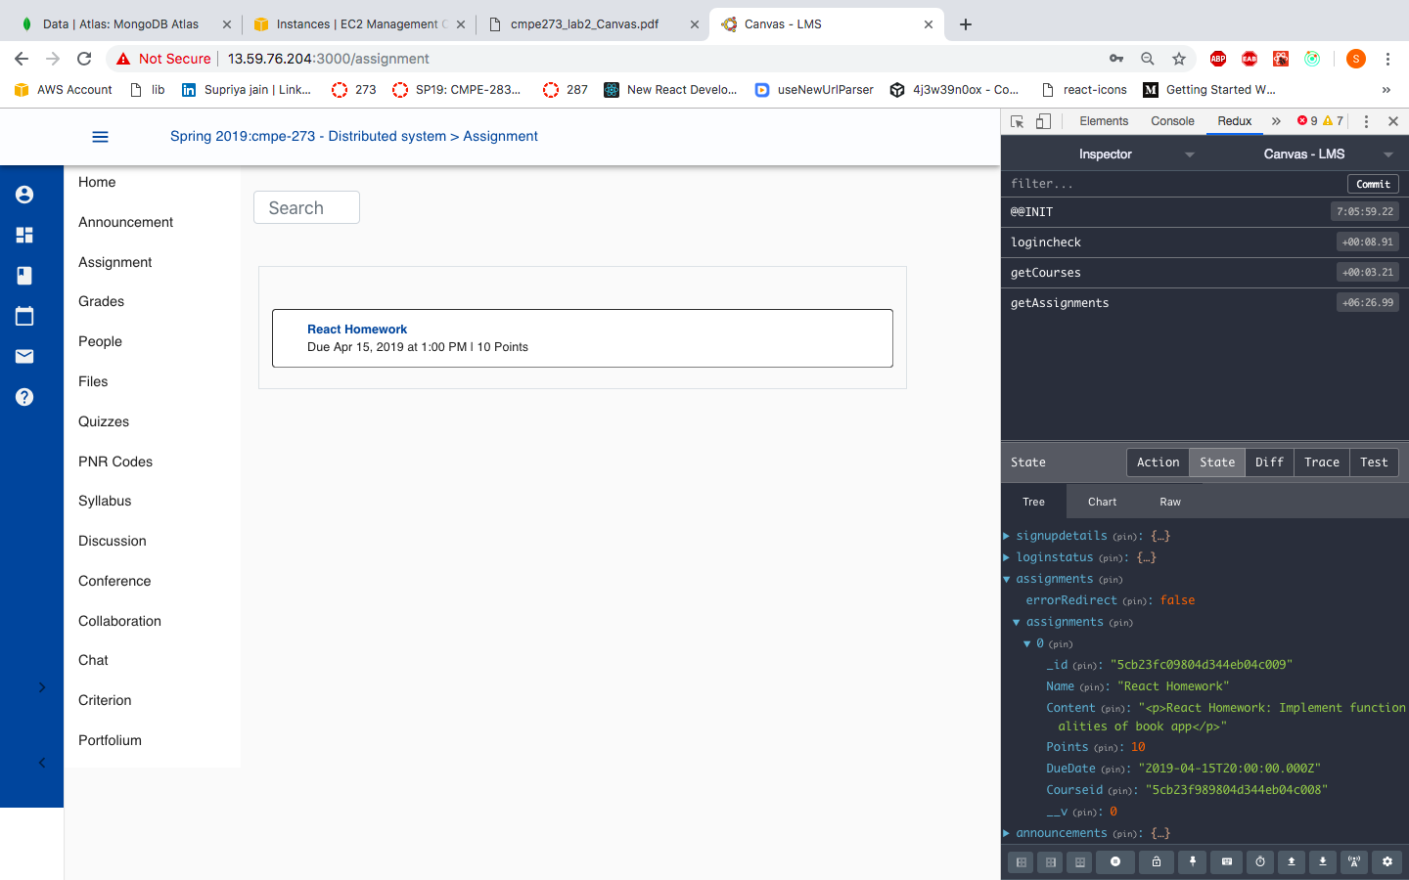

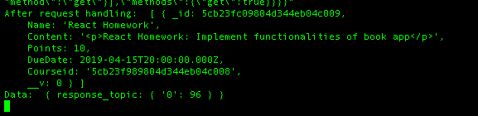

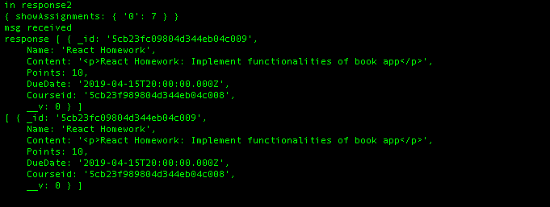

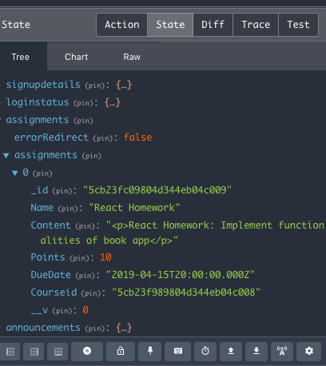

1. If Deadline is after today’s date, then student can submit the assignment.

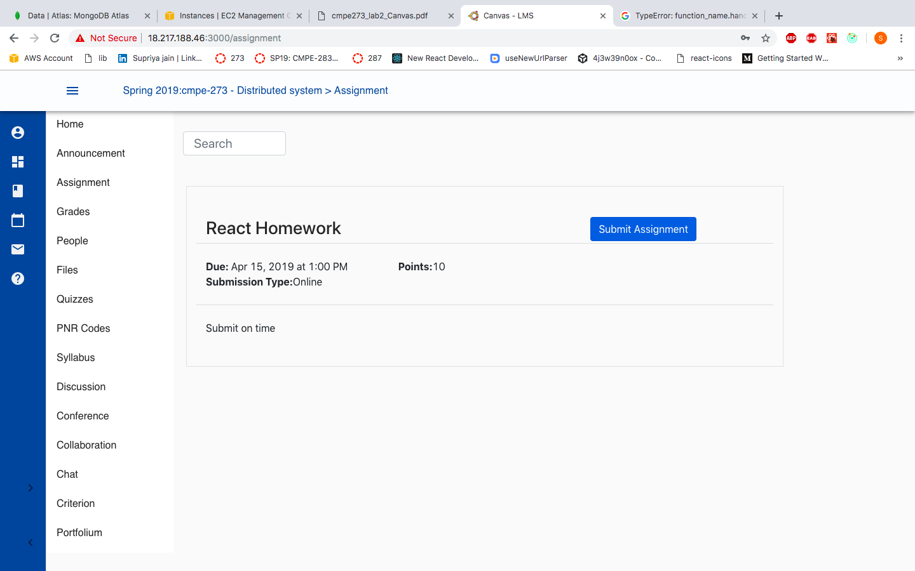

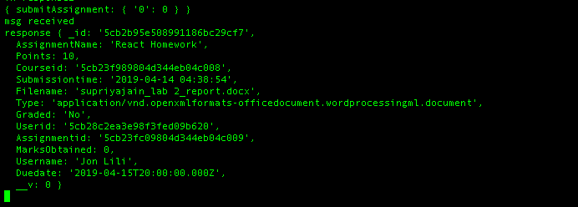

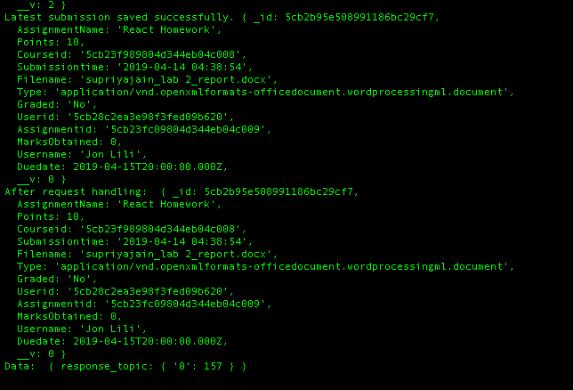

1. If Student has already submitted the assignment, there will an option to Re-Submit the assignment and see previous submitted submissions.

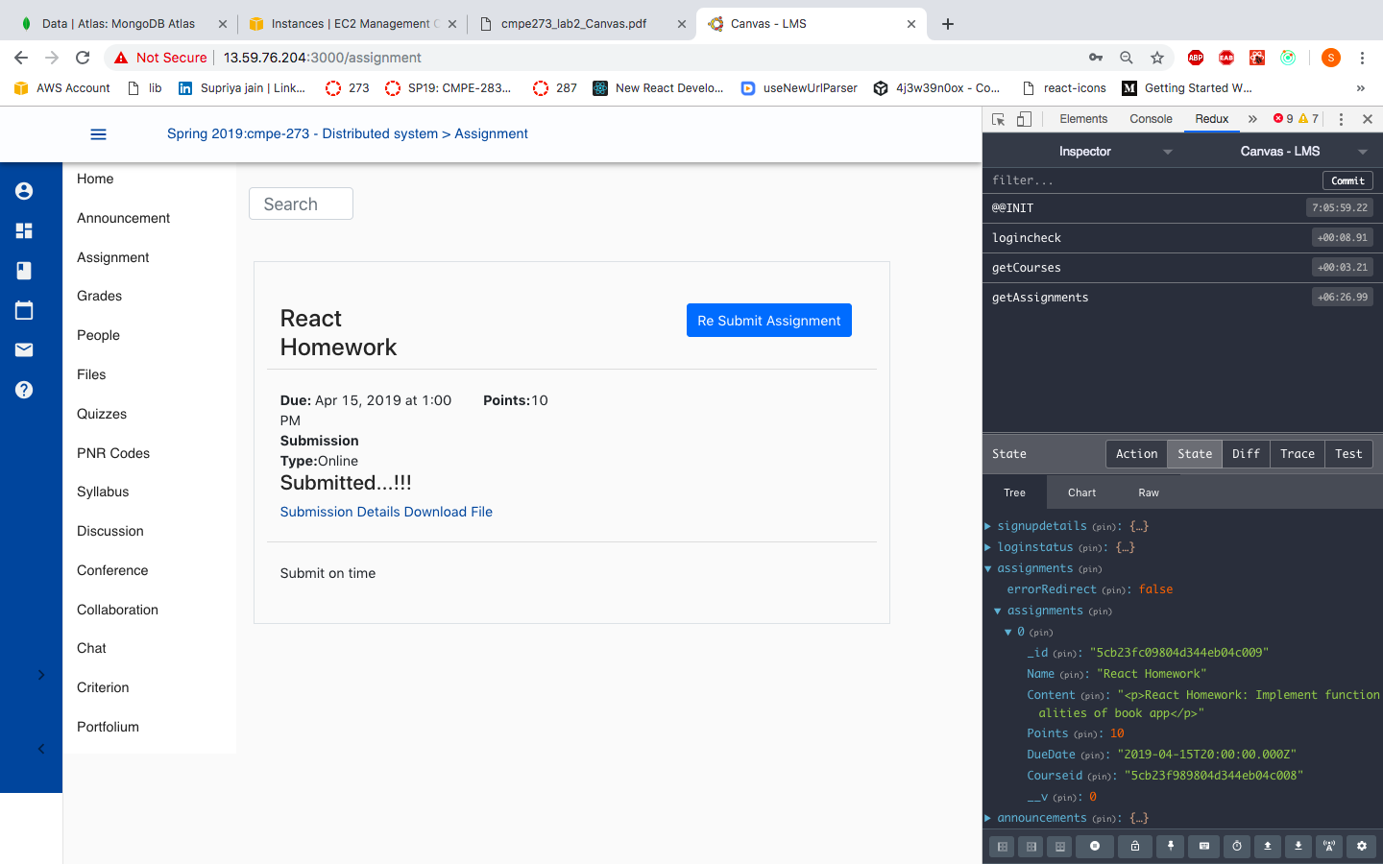

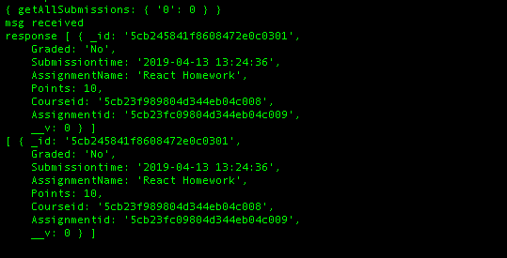

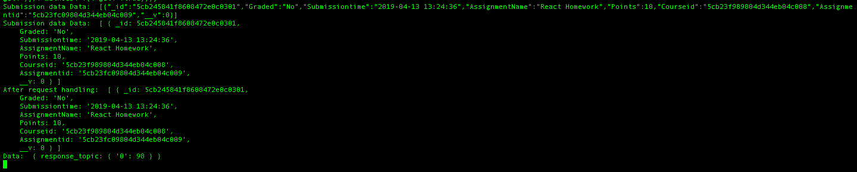

Student can see already submitted assignment submission:

#### **Student: Grades page**

Students can see total grades based on quiz and assignments marks.

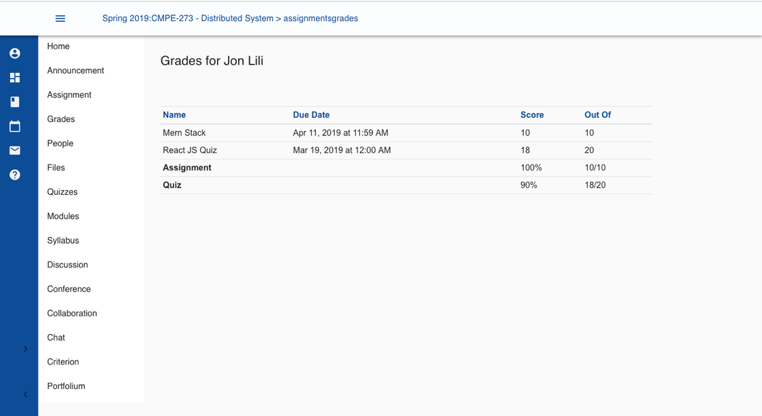

#### **Student: Course Page**

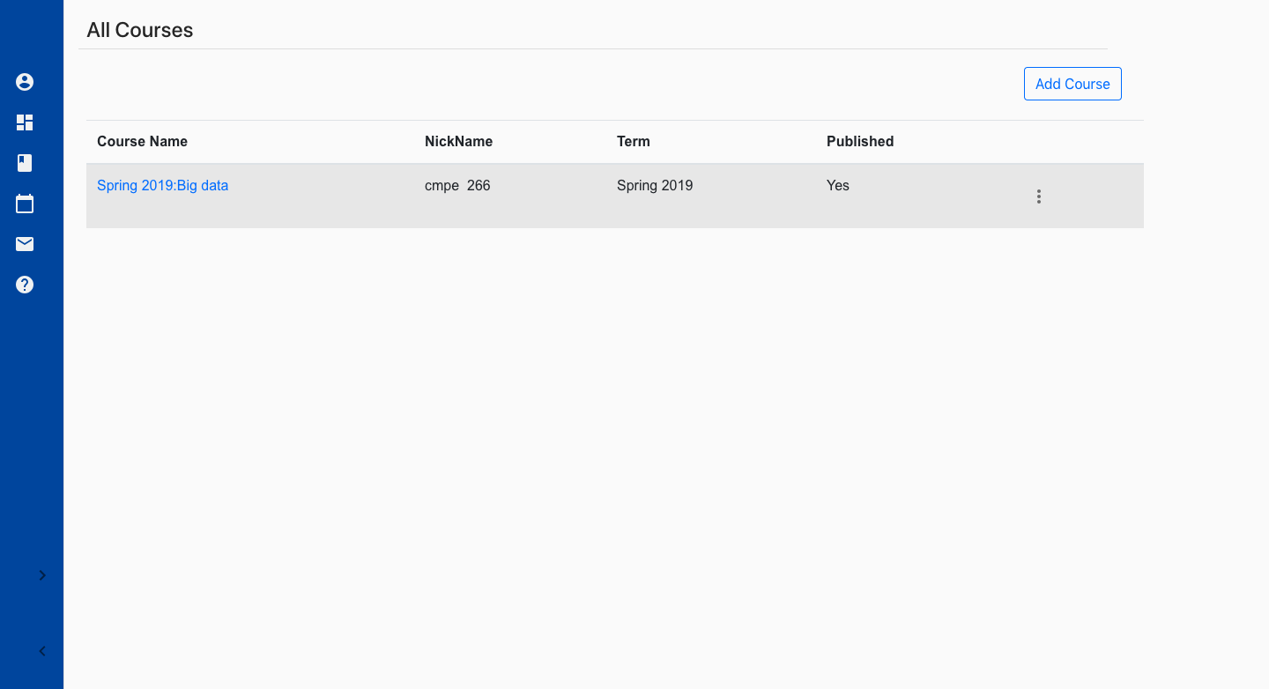

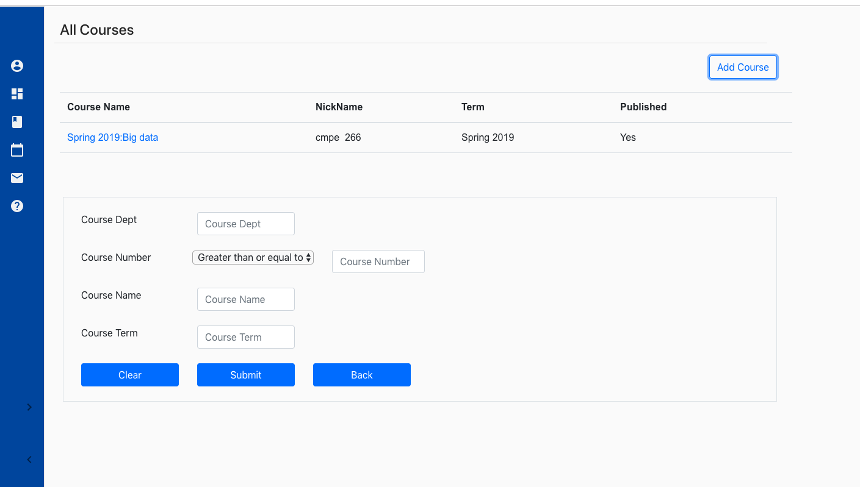

Only those courses which are not enrolled by student will be visible.

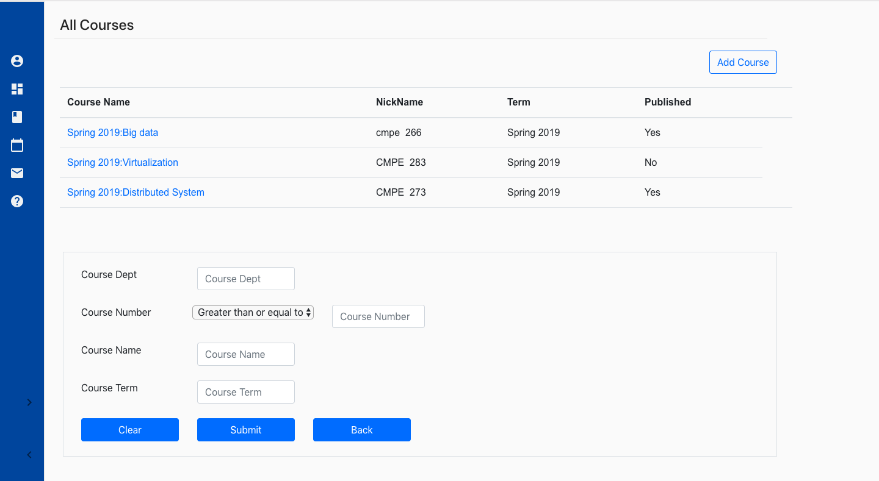

#### **Student: People Page:**

Student will be able to view all the students registered for each particular course.

1. Go to Course -> Click on People tab from the Menulist.

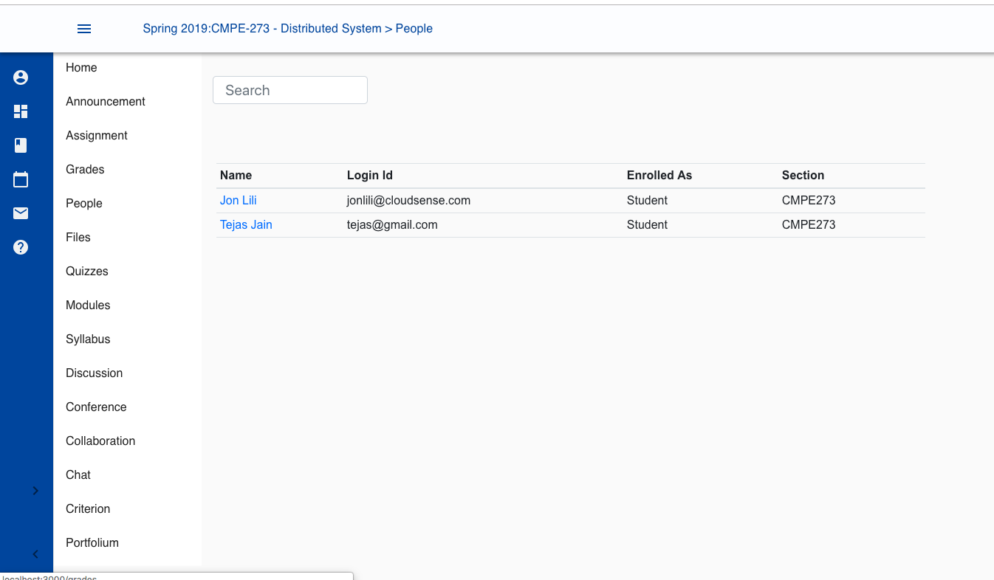

#### **Student: File Page:**

Go to Course -> Click on File tab from the Menulist.

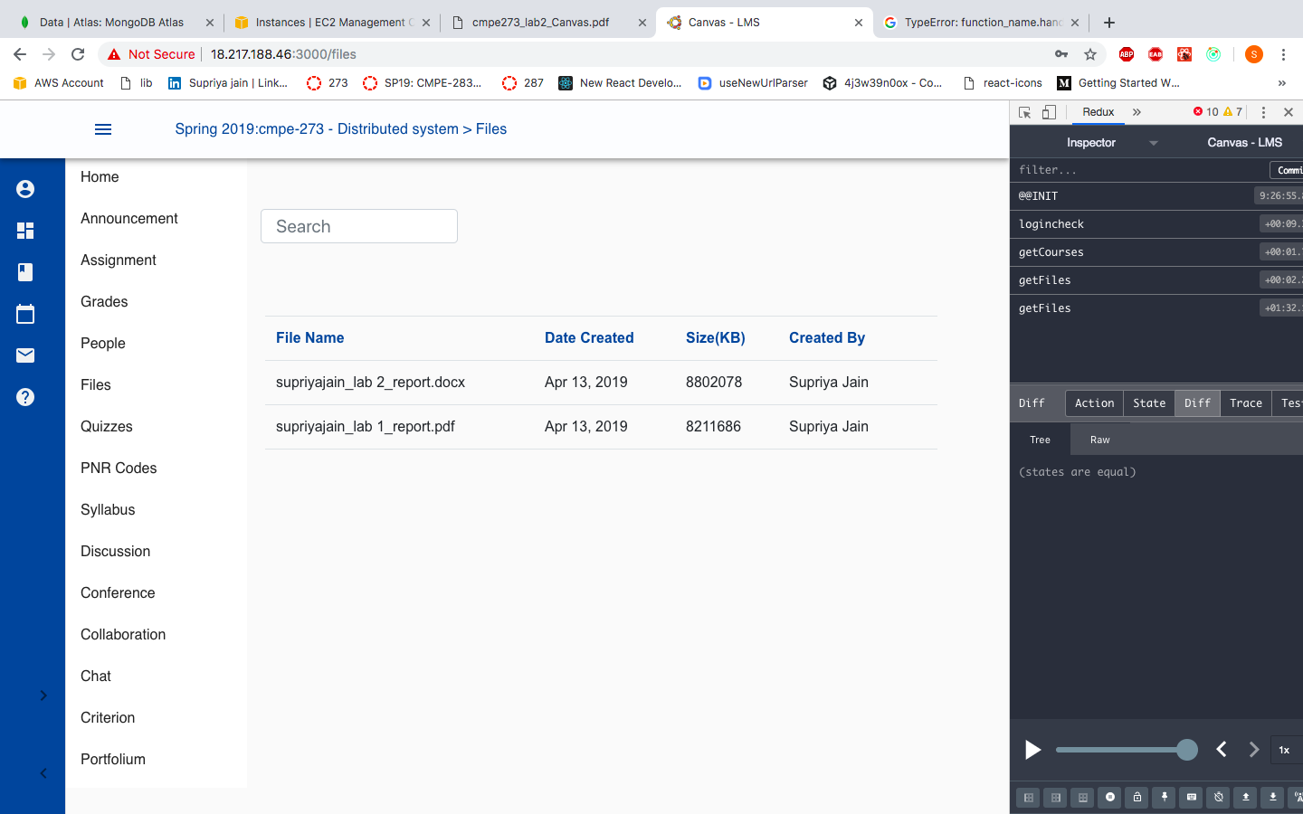

View lecture files:

Go to Course -> Click on People tab from the Menulist. -> Click on the file you want to view from the filename section.

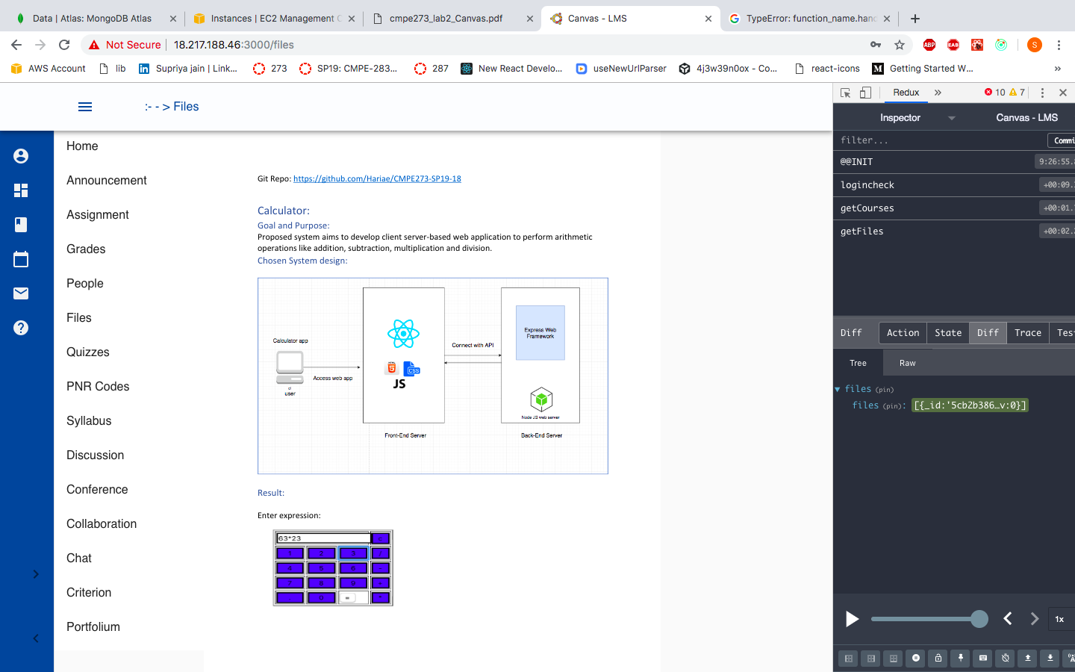

#### **Student: Quiz Page:**

Student can see the quizzes uploaded for the course from the Course-> Quizzes tab

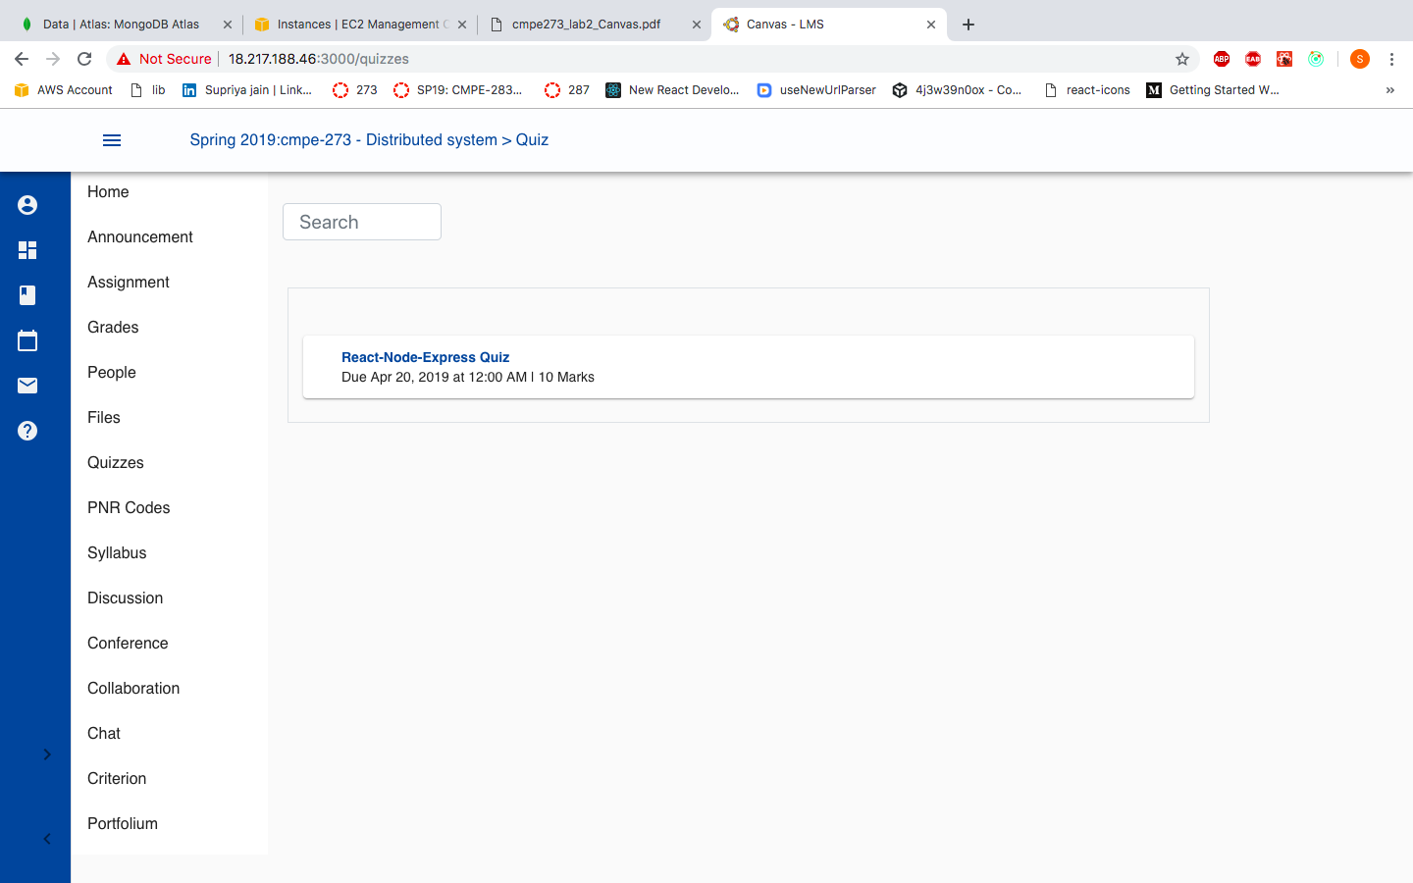

To see the quiz detail, click on the quiz.

If quiz due date is greater than today’s date student that take the quiz. If due date has already been passed, then Take Quiz option will not be displayed.

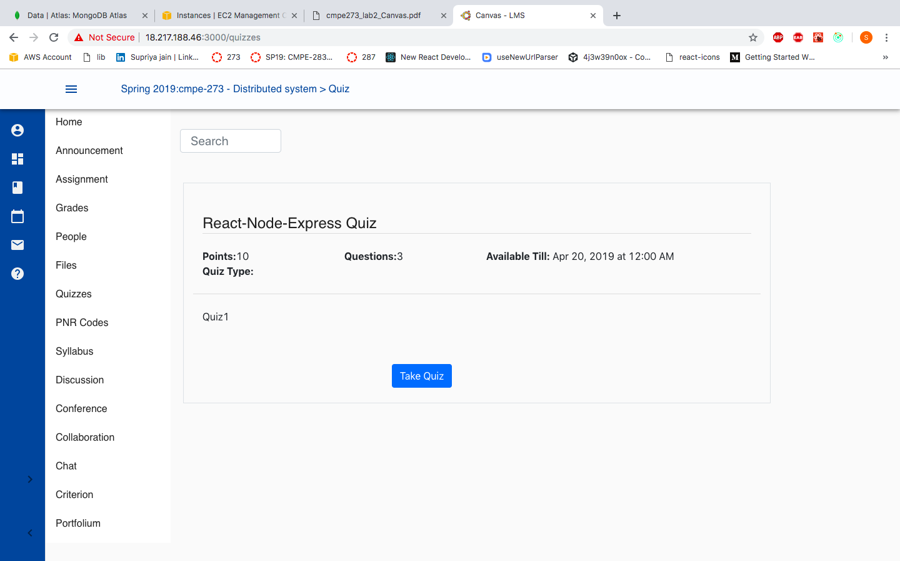

Quiz format will be multiple choice question. Select the right answer from radio button.

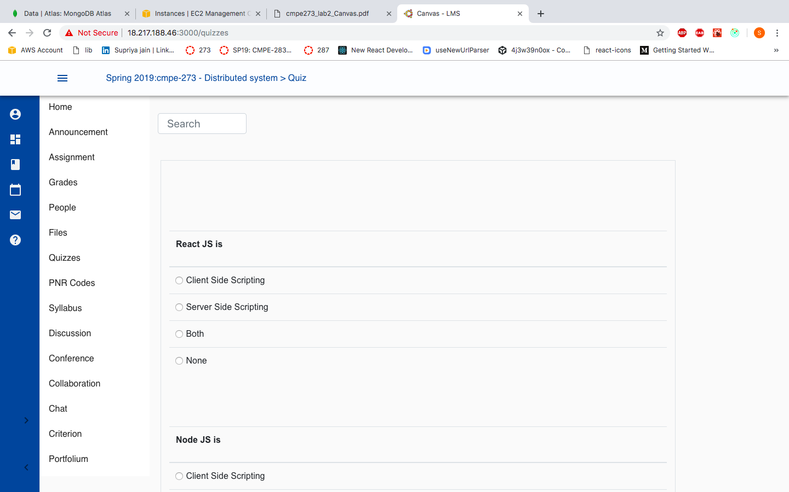

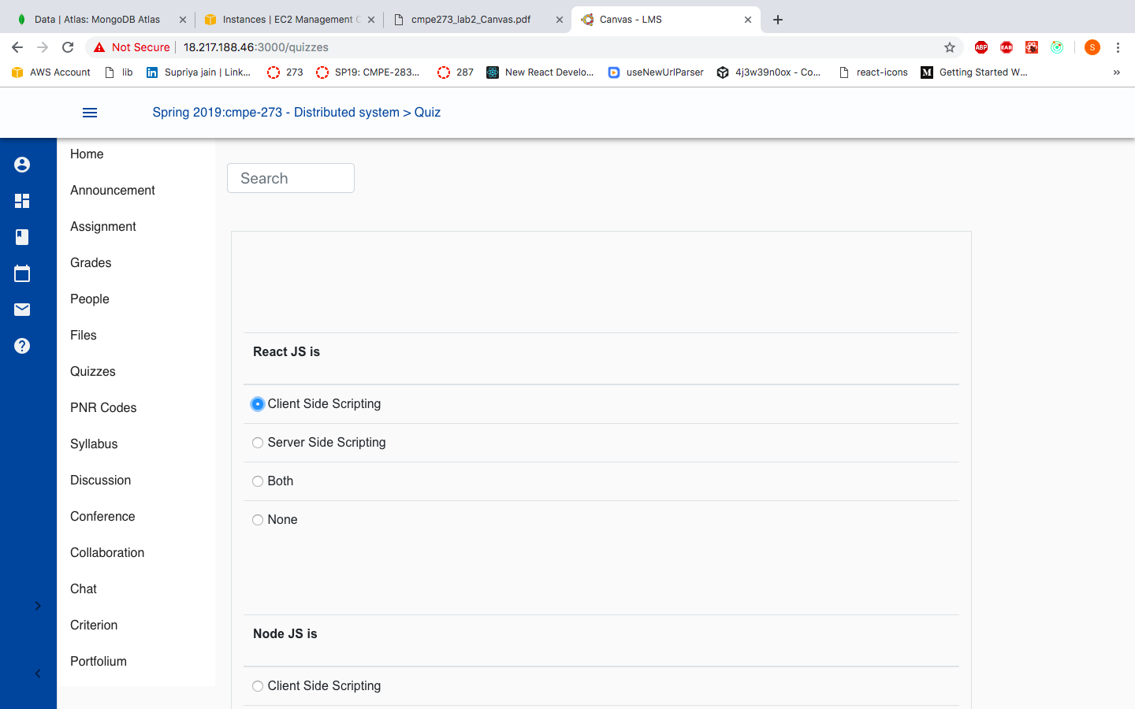

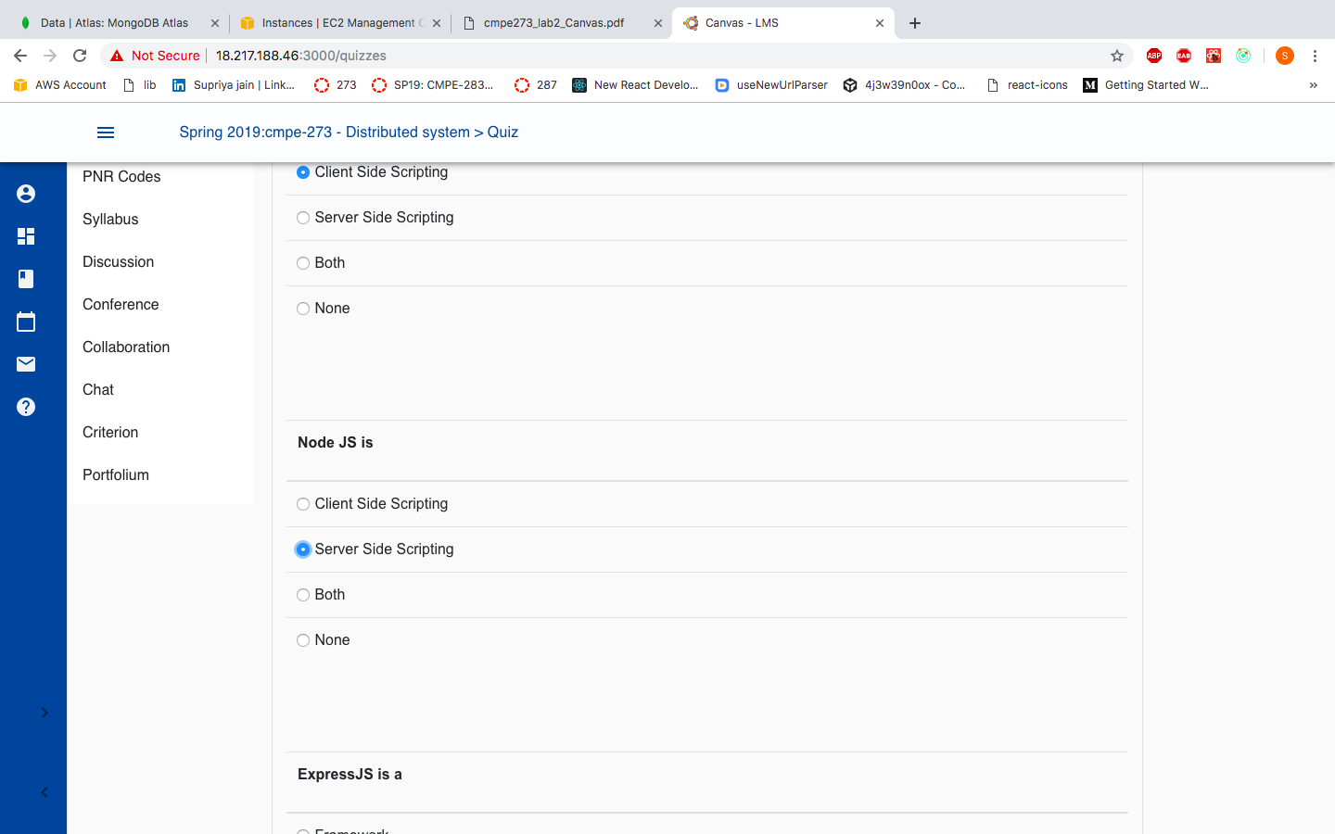

Click on the Submit button to submit the quiz.

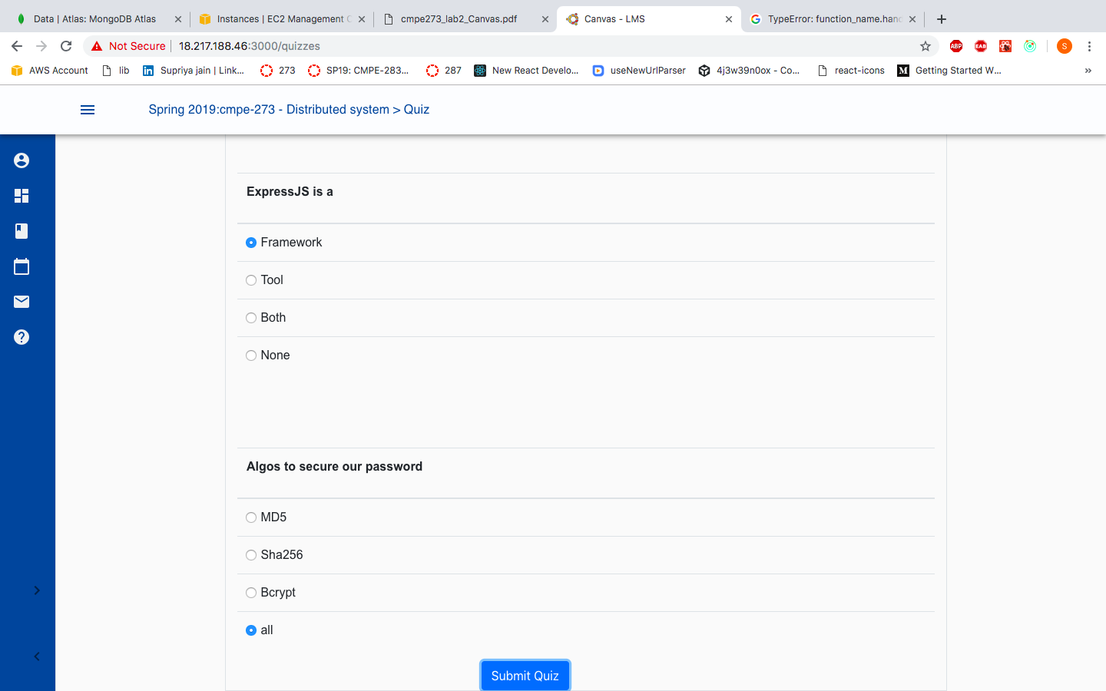

Quiz redux:



##### Mocha Testing:

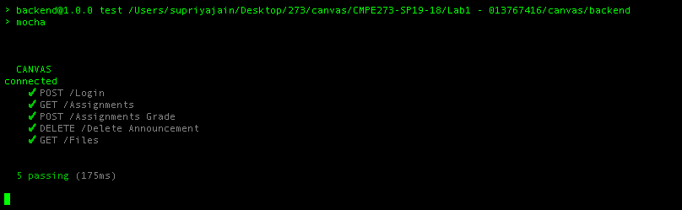

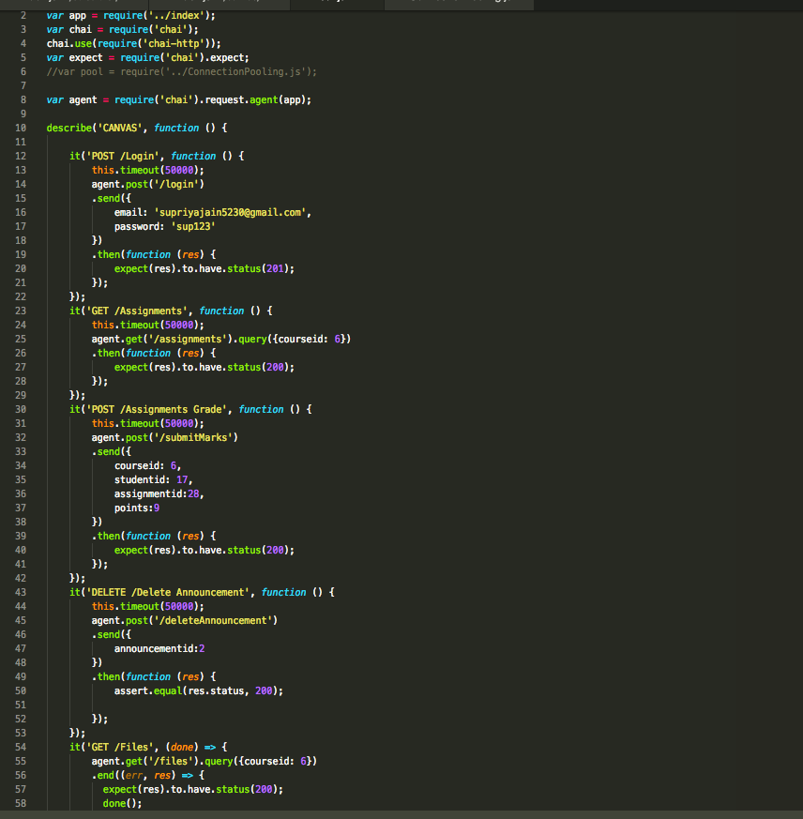

##### JMeter Testing: Without Connection Pooling:

1)100 Users:

2)200 Users:

3)300 Users:

4)400 Users:

5)500 Users:

Git commit history:

|  |
| --- |
|  |